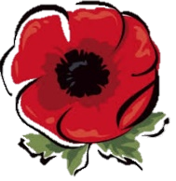
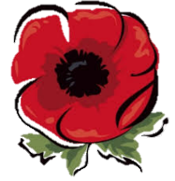
KNOWLEDGE ORGANISER
WORLD WAR I
Main Participating Countries |  |  |  |  |  |  | Major Events
ALLIED POWERS |  |  | CENTRAL POWERS |  |  |  | Event | Image | Description | Date/s | Fact
Country | Date Joined | Death Toll | Country | Date Joined | Death Toll |  | Entangling Alliances | 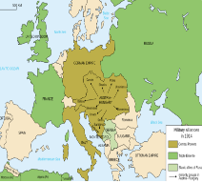 | In the early 20th Century, there was no one dominating European country. Consequently, each of the most powerful countries moved to make alliances with one another. Military defensive pacts were held between the allied powers of France, Great Britain, Russia and others, whilst an opposing central alliance was formed including Germany and Austria-Hungary. | 1879-1914 | Defensive pacts stated that participating countries must aid an ally under attack.
FRANCE | 3rd Aug, 1914 | approx.  1,700,000  4.3% of population in 1914 | GERMAN EMPIRE | 1st Aug, 1914 | approx.  2,500,000  4% of population in 1914
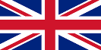  BRITISH EMPIRE | 4th Aug, 1914 | approx.  900,000  2% of population in 1914 | AUSTRIA-HUNGARY  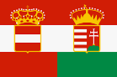 | 28th Jul, 1914 | approx.  1,900,000  3.7% of population in 1914 |  | Assassination of Archduke Franz Ferdinand | 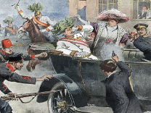 | Archduke Franz Ferdinand, the heir to the Austro-Hungarian throne, and his wife Sophie, were assassinated by Gavrilo Princip, a member of the Serbian Black Hand Society. The aim of the assassination was to make the South Slav provinces a part of Yugoslavia. | 28th June 1914 | Earlier, another assassination attempt against the Archduke had failed.
RUSSIA  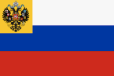 | 1st Aug, 1914 | approx.  3,100,000  13.7% of population in 1914 | OTTOMAN EMPIRE  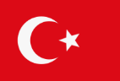 | 31st Oct, 1914 | approx.  3,000,000  14% of population in 1914 |  | July Crisis | 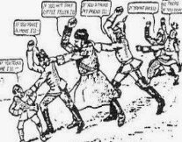 | After Serbia’s failure to make amends for the assassination, Austria-Hungary declared war on them. Russia (in pact with Serbia) declares war on Austria-Hungary, before Germany consequently declares war on Russia. By the 4th August, all of the European powers from the Allied and Central Powers are at war. | July-August 1914 | Britain were the last of the powers to declare war, on 4th August 1914.
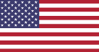  USA | 6th Apr, 1917 | 117,466  0.13% of population in 1914 | BULGARIA  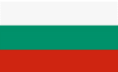 | 12th Oct, 1915 | 187,500  3.4% of population in 1914 |  | Trench Warfare | 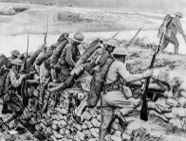 | To prevent enemy advances, both sides built large trenches, which stretched from the North Sea, through Belgium and France. As a result, neither side made much ground from late 1914 until early 1918. Attacks involved going across No Man’s Land (in the middle) where attackers were open to machine gun fire, mines, and shells. Casualties were huge. Life in the trenches were awful, with diseases like trench foot rife. Mustard gas was a war agent used, causing blisters on skin and lungs. It caused excruciating pain and often death. | From September 1914 until November 1918 (the end of the war). | The enemy trenches were generally 50 to 250 metres apart. In between, No Man’s Land was littered with barbed wire, mines, and bodies.
 |  |  |  |  |  |  |  | 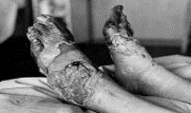
Key People
The British Population – why did they want to fight?  Patriotic and nationalist feeling – many people wanted to fight and defend their country due to the love of their country and their hatred towards others e.g. Germany due to the rivalry between them.  Adventure – many men had never been abroad before  No Coward – people wanted to avoid being called a coward and being given a white feather.  Propaganda was also very powerful e.g. posters! |  |  | 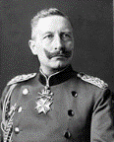  Kaiser Wilhelm II – (1859-1941) was the last German Emperor (Kaiser), reigning between 15th June 1888 until 9th November 1918. Wilhelm was a grandchild of Queen Victoria, and was related to many of the monarchs of Europe, including George V of the UK and Nicholas II of Russia. His support for Austria-Hungary in the crisis of July 1914 was a leading factor in the outbreak of World War I. Many sources suggest that he was not respected as a leader, and as a result, his two leading generals Paul von Hindenburg and Erich Ludendorff dictated most of German policy and strategy during the war. He abdicated in 1918, and fled to the Netherlands. |  |  |  | Gallipoli Campaign | 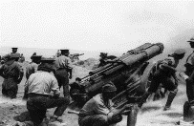 | The Gallipoli campaign was an unsuccessful attempt by the Allies to control the sea route from Europe to Russia. It included a failed naval attack in February 1915, and a major land invasion on 25th April, which resulted in major losses to the Ottoman Empire. | 19th February 1915 – 9th January 1916 | The Allies eventually evacuated in Dec 1915/ Jan 1916.
 |  |  |  |  |  |  | Battle of the Somme | 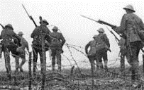 | The Battle of the Somme was the largest battle of World War I on the Western Front. More than 3 million fought in the battle, with more than 1 million killed or injured. At the end of the battle, the Allies had advanced 6km. | 1st July 1916 – 18th November 1916 | The battle is known for being the first use of the tank.
 |  |  |  |  |  |  | America Declares War | 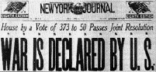 | President Woodrow Wilson declared war on Germany, citing Germany’s violation of its pledge to suspend unrestricted German warfare in the Northern Atlantic and Mediterranean. This had caused sinking of US ships. | 6th April 1917 | The arrival of fresh US troops helped to turn the war.
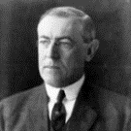  Woodrow Wilson – (1856-1924) was the 28th President of the United States, serving between 1913 and 1921. At the outbreak of World War I, in 1914, the US was neutral, but remained an important supplier to Great Britain and the Allies. However, after 2 ½ years of war, America declared war on Germany on 6th April 1917, after Germany continued to attack neutral boats and ships. In early 1918, Wilson gave his outline of 14 points that he thought would bring lasting peace. This influenced the eventual Treaty of Versailles. He received the 1919 Nobel Peace Prize for his efforts. |  |  | 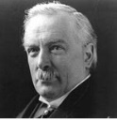  David Lloyd George – (1863-1945) was the Prime Minister of the United Kingdom throughout the latter part of the war effort, and in the years following the war. He was integral to reorganising the Allied military strategy to work more cohesively under one military commander. Lloyd George also played an important role after the war, being one of the ‘Big Three’ (alongside the leaders of France and the US) to negotiate the Treaty of Versailles with Germany. He represented the halfway point between the harsh demands of Clemenceau and the more lenient requests of Wilson.
 |  |  |  |  |  |  | Second Battle of Marne | 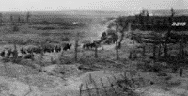 | The Second Battle of Marne was the last major German offensive in the war. They were defeated as the Allies counter-attacked. This triggered the start of the Allied advanced which led to the Armistice 100 days later. | 15th July - 6th August 1918 | There were 168,000 German casualties.
 |  |  |  |  |  |  | Armistice of 11th November | 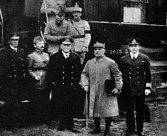 | The Armistice of the 11th November 1918 signalled the end of the fighting between the Allies and Germany. Previous armistices had already been agreed with the other central powers. It came into force at 11am. It marked a victory for the Allies and defeat for Germany although was not officially a German surrender. | 11th November 1918 | The fighting ended on the 11th hour of the 11th day of the 11th month in 1918.
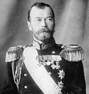  Tsar Nicholas II – (1868-1918) was the last Emperor of Russia, ruling from 1894 until his forced abdication on 2nd March 1917. Throughout his regin, Russia fell from being one of the foremost great powers of the world, to economic and military collapse. These factors, coupled with the perception of Nicholas’ week leadership, led to the events of the Russian Revolution, Nicholas’ abdication, and his eventual execution. The Russians’ catastrophic losses forced them to leave the war effort before the end of the war, with Russia eventually becoming a part of the communist Soviet Union. |  |  | 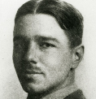  Wilfred Owen – (1893-1918) Wilfred Edward Salter Owen was a British poet and soldier. He was one of the most prominent World War I poets, detailing the horrors of trench warfare in a similar style to his mentor: Sigfried Sassoon. His poetry brought a sense of realism to public perceptions of war, in stark contrast to the earlier works of poets such as Rupert Brooke. He composed almost all of his poetry in just over a year, from August 1917 to September 1918. Among the most famous are Dulce et Decorum est and Anthem for Doomed Youth. He was killed one week before the end of the war.
 |  |  |  |  |  |  | The Treaty of Versailles | 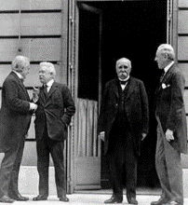 | The Treaty of Versailles was the most important of the peace treaties bringing to an end World War I, ending conflict between Germany and the Allied Powers. It was signed in Versailles, but mostly negotiated in Paris. The most contentious of the requirements in the peace treaty was that Germany had to accept responsibility for all of the loss and damage in the war. They had to make massive repayments to other countries. | 28th June 1919 | Many suggest that the treaty was too harsh on Germany, and created tensions which partially escalated World War II.

15 Jul 1918 – The Allies decisively win at the Second Battle of Marne.
11 Nov 1918 – Armistice signed. The fighting ends.
6 Apr 1917 – The U.S enters the war, declaring war on Germany.
8 Mar 1917 – The Russian Revolution begins. Tsar Nicholas II is removed from power.
1 Jul 1916 – The Battle of the Somme begins. Over 1 million soldiers will be killed or wounded
25 Apr 1915 – The Ottomans defeat the Allies at the Battle of Gallipoli.
11 Nov 1914 – The Ottoman Empire declares war on the Allies.
Sep 5-12 1914 – The advancing German army is stopped by British and French forces before Paris. 4 years of trench warfare begins.
Aug 1-4 1914 – Keeping promises to their allies, Germany, France, and Britain all enter the war.
28 Jul 1914 – Austria-Hungary declares war on Serbia. Russia steps in to help Serbia
28 Jun, 1914 – Archduke Franz Ferdinand is killed by a Serbian
Timeline of Major Events

