January 2022

Dear Parent/Carer,

**Re: ‘Matilda JR.’ whole school production 2022**

**PRINCIPAL SCHOOL CHILDREN**

Performers have been asked to provide their own basic costumes:

**Girls:**

1. ROUND collared white shirt from ASDA or alternative retailer, short-sleeves/long-sleeves, but must have a **round collar**. It may be a good idea to get two as they will be worn for all rehearsals and may need washing in between.

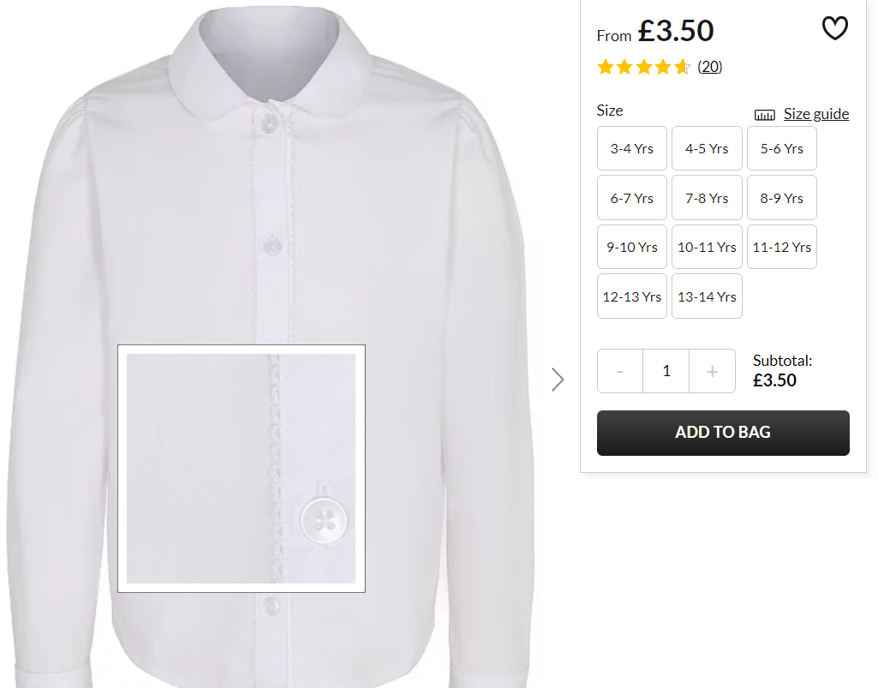

**Boys:**

1. **White** shirt with short-sleeves/long-sleeves. It may be a good idea to get two as they will be worn for all rehearsals and may need washing in between.

2. **Black** school shoes & **black** ‘PE pumps’ for gym scene

3. **Grey** school shorts

4. **Grey**  v-neck jumper from ASDA or alternative retailer, long sleeves, but must be v-neck.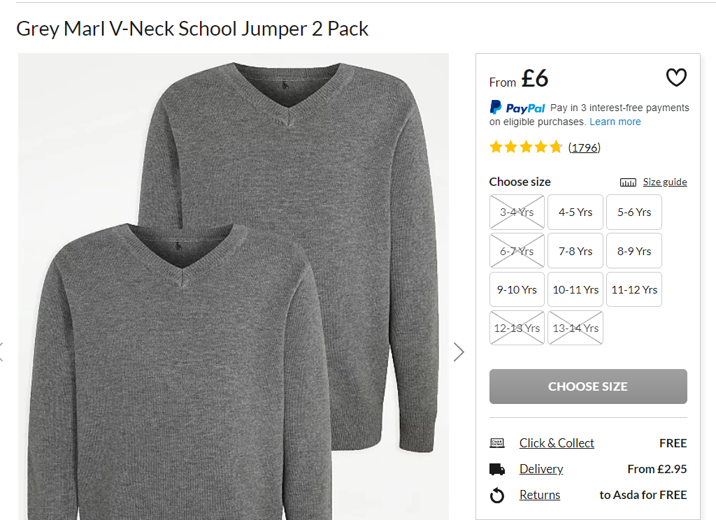

5. **Grey** socks

2. **Black** school shoes & **black** ‘PE pumps’ for gym scene

3. **Grey** pinafore dress from Amazon or alternative retailer

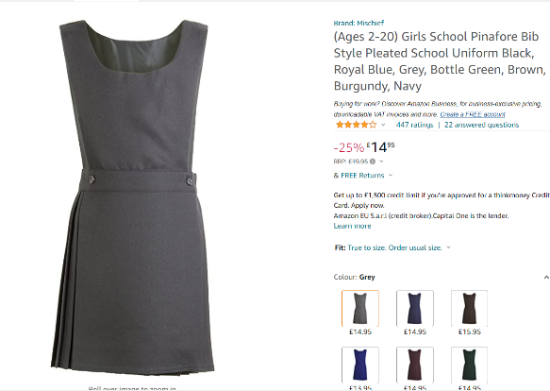

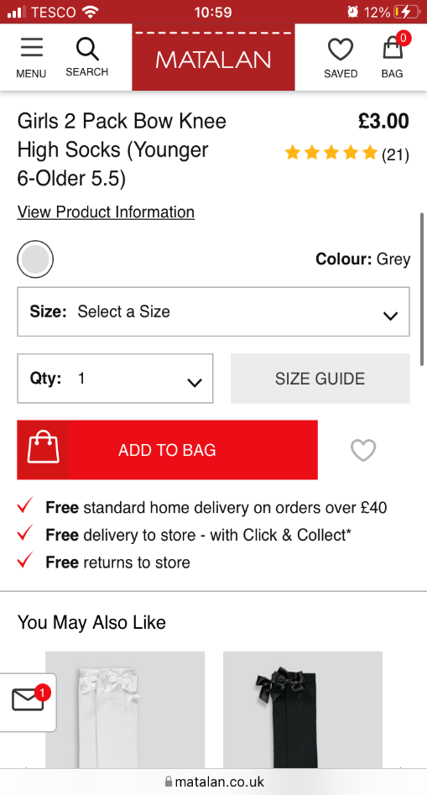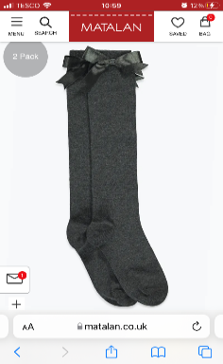

3. **Grey** knee-high socks, from Matalan or alternative

retailer. eg: Asda

*Blazers will be provided.*

Any questions, please get in touch.

Yours faithfully,

Mrs Ventress

Costume Manager

[justine.ventress@charlton.uk.com](mailto:liz.upton1@charlton.uk.com)