January 2020
Dear Parent/Carer,

Re: ‘School of Rock’ whole school production 2020
TEACHERS (Not PE teacher)
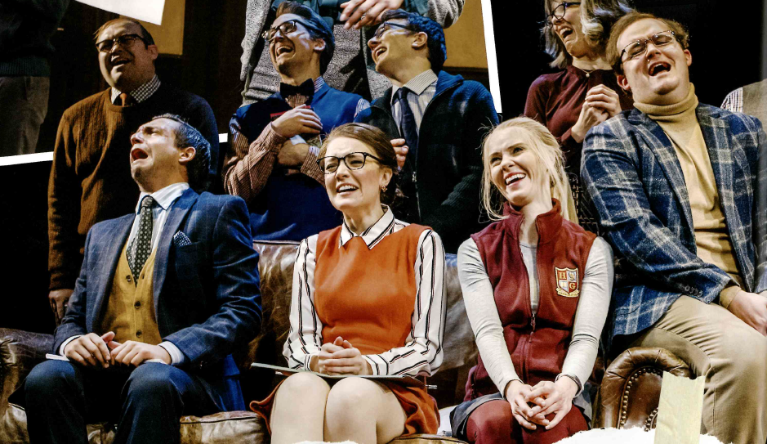
Performers have been asked to provide their own basic costumes:

Girls:
No thank you | Yes please
GREEN/TEAL  - Black  - Grey  - ‘school’ shirts/uniform  - denim | Colours  Patterns  Stripes  ‘grown up’ clothes

SUGGESTIONS:
Knee length pencil skirt/dress
blouse
suit jacket
cardigan
court shoes
pearl necklace
fake glasses; hair in a bun/neat

Boys:
SUGGESTIONS:
Trousers
shirt/thin polo necked jumper under a jacket
waistcoat – knitted or tailored
cardigan/jumper
suit jacket
corduroy
tie
fake glasses
neat hair

No thank you | Yes please
GREEN/TEAL  - Black  - Grey  - ‘school’ shirts/uniform  - denim | Colours  Patterns  Stripes  ‘grown up’ clothes  corduroy  tweed

Yours sincerely,

Mrs Upton
Costume Manager
liz.upton1@charlton.uk.com

