January 2020
Dear Parent/Carer,

Re: ‘School of Rock’ whole school production 2020

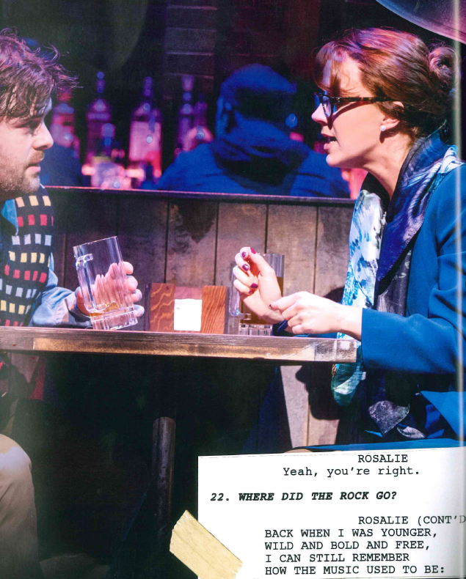
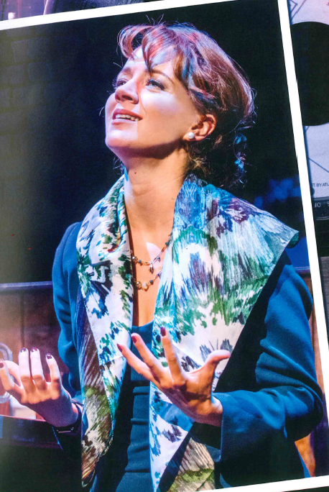
Rosalie Mullins
Performers have been asked to provide their own basic costumes where possible:

1. Blue/teal/green dress and jacket ladies suit
2. Tan tights
3. blue/white scarf
4. Court shoes (New Yorkers?)
5. Black glasses
6. Hair in a nice low bun/neat

7. Leather jacket ( we have one at school)
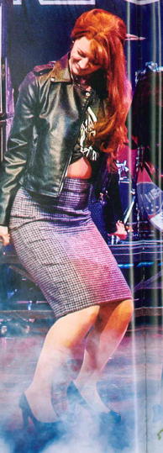

Yours sincerely,

Mrs Upton
Costume Manager
liz.upton1@charlton.uk.com

