January 2020
Dear Parent/Carer,

Re: ‘School of Rock’ whole school production 2020
Ned Schneebly
Performers have been asked to provide their own basic costumes:

Everyday outfit:
1. Loud pink and blue/lilac tartan shirt
2. Green tie
3. Brown trousers
4. brown belt
5. brown shoes
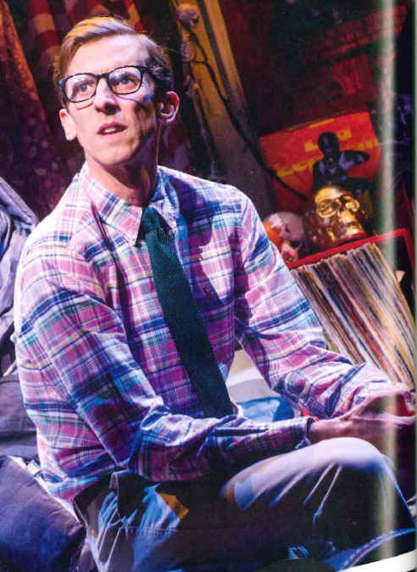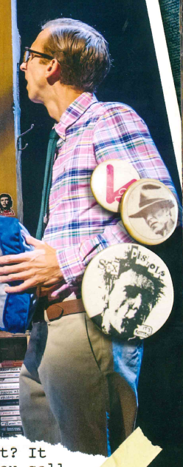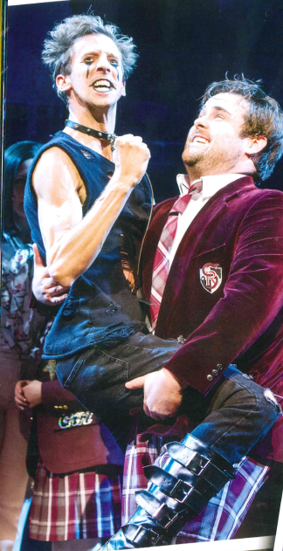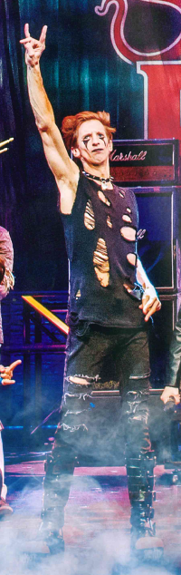

Rock outfit; Suggestions of possible outfits:

- denim/PVC/leather/fishnet/black/purple/dark colours
- leggings, leather waistcoat, black mini skirt/shorts
- ‘Clompy’ shoes/DMs
- bandanas (dark/subdued colours, not bright colours
- YES T-shirts of rock bands such as ACDC/Guns’n’Roses/Kiss etc
- NO T-shirts with other logos or religious symbols/crosses or offensive artwork
- studded black wrist band/neck collar/belts
- multiple thin leather/black wrist bands
- fake tattoos
(but please nothing too provocative/revealing!)

Black fingerless gloves

Yours sincerely,

Mrs Upton
Costume Manager
liz.upton1@charlton.uk.com

