January 2020
Dear Parent/Carer,

Re: ‘School of Rock’ whole school production 2020

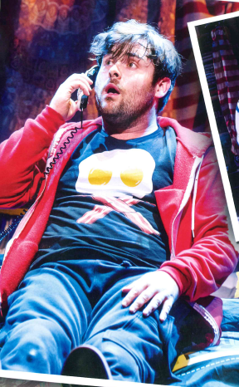
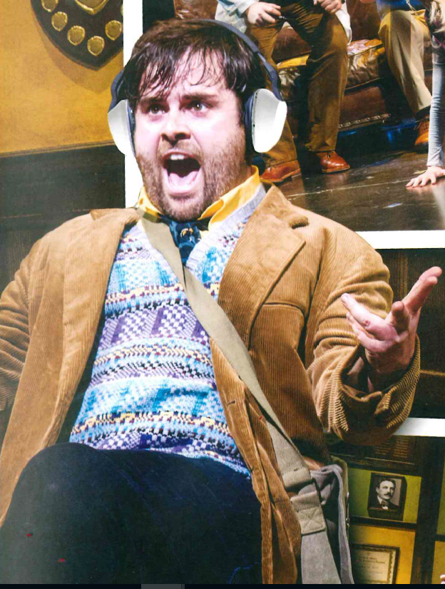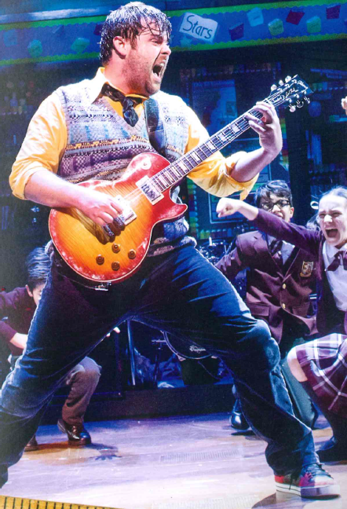
Dewey Finn
Performers have been asked to provide their own basic costumes where possible:

Think Scruffy!

1. Black skull and crossbones t-shirt.
If the two Deweys could buy 2 it would be cheaper?
2. baggy dark cargo pants/black baggy jeans
3. Red scruffyconverse or scruffy trainers (charity shops?)
4. Red hooded top
5. Yellow Long sleeved large shirt
6. Hand knitted tank top mismatched
7. Corduroy Mustard-coloured jacket
8. White school shirt, short or long sleeved
9. Long maroon socks
10. Clashing bad taste green/blue tie

Yours sincerely,

Mrs Upton
Costume Manager
liz.upton1@charlton.uk.com

