January 2020
Dear Parent/Carer,

Re: ‘School of Rock’ whole school production 2020
CHORUS AND PRINCIPAL DANCERS
Performers have been asked to provide their own basic costumes:

Girls:

1. ROUND collared white shirt from ASDA or alternative retailer, short-sleeves/long-sleeves, but must have a round collar. It may be a good idea to get two as they will be worn for all rehearsals and may need washing in between.
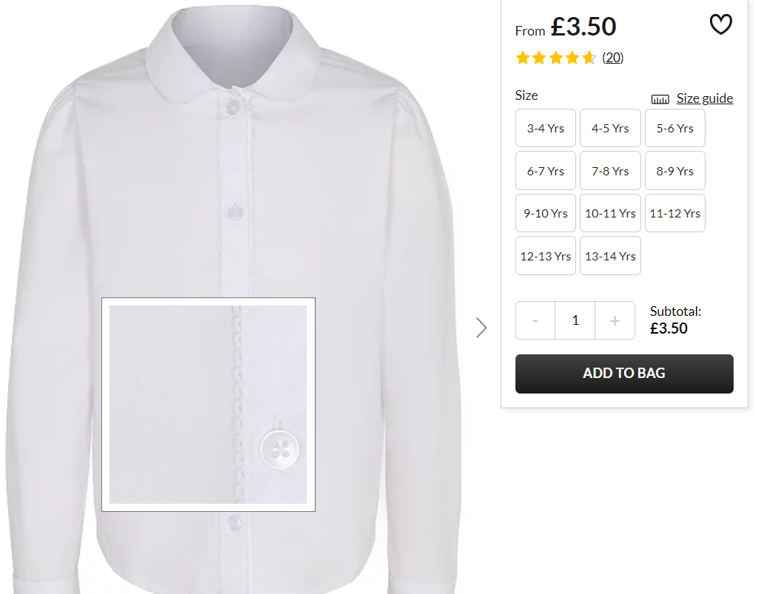
Boys:

1. White shirt with short-sleeves/long-sleeves. It may be a good idea to get two as they will be worn for all rehearsals and may need washing in between.
2. Black school shoes
3. Grey school trousers
3. Grey socks

2. Black school shoes

3. Burgundy/maroon knee-high socks. eg:
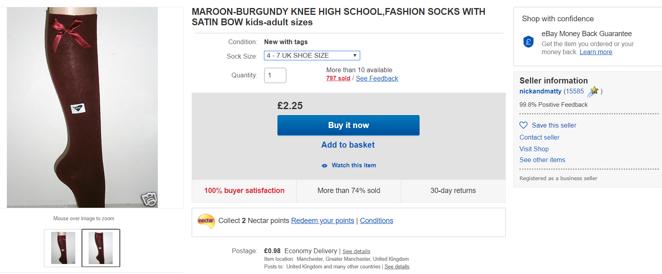

Skirts will be provided.
BOYS AND GIRLS: (ALL)

4. Rock outfit; Suggestions of possible outfits:
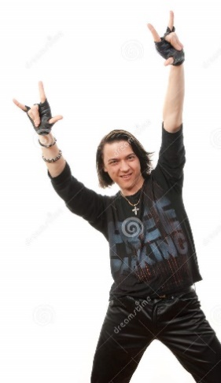
- denim/PVC/leather/fishnet/black/purple/dark colours
- leggings, leather waistcoat, black mini skirt/shorts
- ‘Clompy’ shoes/DMs
- bandanas (dark/subdued colours, not bright colours
- YES T-shirts of rock bands such as ACDC/Guns’n’Roses/Kiss etc
- NO T-shirts with other logos or religious symbols/crosses or offensive artwork
- studded black wrist band/neck collar/belts
- multiple thin leather/black wrist bands
- fake tattoos
(but please nothing too provocative/revealing!)

5. Accessories for ‘rocking up’ the uniform:
Black fingerless gloves
Hair accessories: black/dark/purple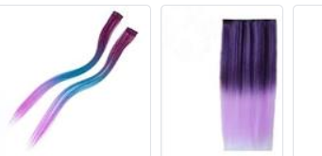

red braces/belts
stripy socks: 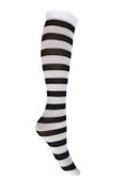
Yours sincerely,

Mrs Upton
Costume Manager
liz.upton1@charlton.uk.com

