January 2020
Dear Parent/Carer,

Re: ‘School of Rock’ whole school production 2020
CHOIR
Performers have been asked to provide their own basic costumes:

Girls:

1. ROUND collared white shirt from ASDA or alternative retailer, short-sleeves/long-sleeves, but must have a round collar. It may be a good idea to get two as they will be worn for all rehearsals and may need washing in between.
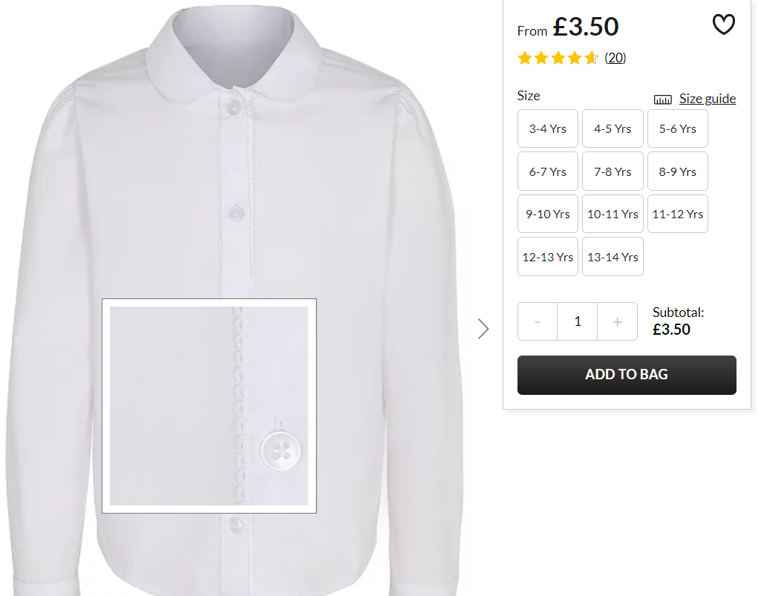

2. Black school shoes

3. Burgundy/maroon knee-high socks. eg:
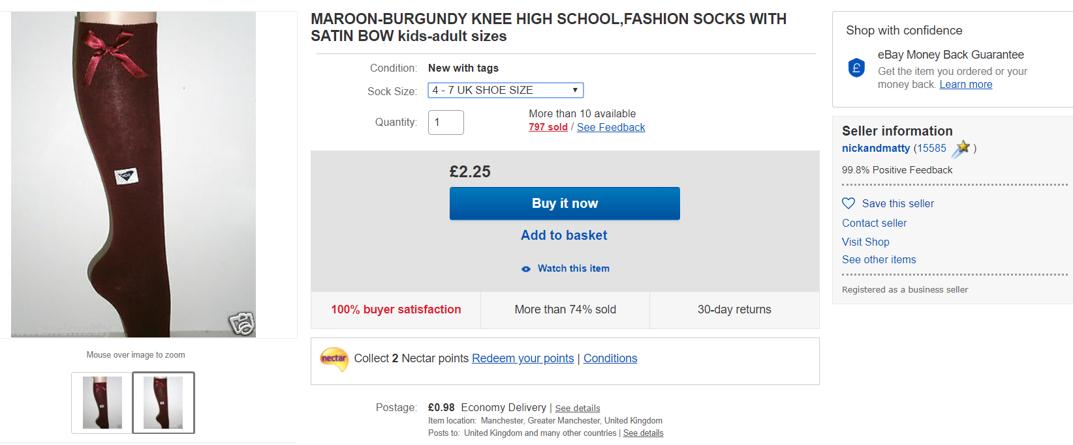

Skirts will be provided.
Boys:

1. White shirt with short-sleeves/long-sleeves. It may be a good idea to get two as they will be worn for all rehearsals and may need washing in between.
2. Black school shoes
3. Grey school trousers
3. Grey socks

Yours sincerely,

Mrs Upton
Costume Manager
liz.upton1@charlton.uk.com

