January 2020
Dear Parent/Carer,

Re: ‘School of Rock’ whole school production 2020
BACK STAGE CREW

Back stage crew are asked to wear the following:

Girls and Boys:
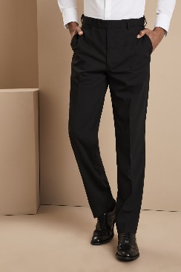
1. Black long-sleeved t-shirt
2. Black trousers
3. Black socks
4. Black shoes/trainers
NO LOGOS

Yours sincerely,

Mrs Upton
Costume Manager
liz.upton1@charlton.uk.com

