January 2026

Dear Parent/Carer,

‘Legally Blonde Jnr.’ whole school production 2026

Performers have been asked to provide their own costumes, which they will need for 1st February. We will also be providing some of the costumes. Please see the tables below which covers the main numbers from the show that each ensemble cast member will be involved in along with the costume you will need to provide (if it’s blank, we are providing).

There are images to support this. Following this, there is a principal cast list with a description of costume they will need. Some are highlighted as “hired” meaning we will provide.

If you have any issues with the costumes below, please don’t hesitate to contact me and let me know.

Thank you again for your support with everything on the run up to the show

Yours sincerely,
Amy Crampsie

Principal Dancers
NUMBER | COSTUME
OMIG YOU GUYS | - BLACK LEGGINGS  - WHITE PUMPS  - ACCESSORIES- SCARFS, JACKETS/BLAZER, BOWS- PASTEL BLUE, GREEN, WHITE
WHAT YOU WANT | - BLACK LEGGINGS  - WHITE PUMPS  - COLOURFUL HAT/BASEBALL CAP
SO MUCH BETTER | SAME AS ABOVE
WHIPPED INTO SHAPE | FUNKY ACTIVE WEAR

Solo Dancers:
NUMBER | COSTUME
OMIG YOU GUYS | - WHITE PUMPS  - TAN TIGHTS
SERIOUS | - BLACK LEOTARD  - BLACK TIGHTS  - BLACK JAZZ SHOES
WHAT YOU WANT | COLOURFUL HAT/BASEBALL CAP
SO MUCH BETTER | SAME AS ABOVE
WHIPPED INTO SHAPE | FUNKY ACTIVE WEAR
BASE | - BLACK LEOTARD  - BLACK JAZZ SHOES  - BLACK TIGHTS

Ensemble:
CHARACTER | COSTUME
FRAT BOYS | - HAWAIIN SHIRT  - WHITE TEE  - JEANS
DELTA NU | FASHIONABLE CONTEMPORARY OUTFITS: JEANS/JEGGINGS FOR COMFORT, WHITES, LILACS, BRIGHT COLOURS, GREENS, BLUES HATS, BELTS TO MAKE INDIVIDUAL.
HARVARD UNI STUDENTS | SMART ATTIRE. GREYS, NAVY’S/BEIGE/AUTUMNUL COLOURS (SEE IMAGES BELOW FOR IDEAS)  - JUMPER/JUMPER VESTS, BEIGE, GREY.  - JEANS/BLACK BOTTOMS  - WHITE SHIRT  - BLAZERS
NUMBER/SCENE | COSTUME
OMIG YOU GUYS | DELTA NU COSTUME (SEE ABOVE)
WHAT YOU WANT | - DELTA NU/FRAT BOY COSTUME (SEE ABOVE)  - COLOURFUL HAT/BASEBALL CAP
HARVARD UNI STUDENTS | SMART ATTIRE. GREYS, NAVY’S/BEIGE/AUTUMNUL COLOURS (SEE IMAGES BELOW FOR IDEAS)  - JUMPER/JUMPER VESTS, BEIGE, GREY.  - JEANS/BLACK BOTTOMS  - WHITE SHIRT  - BLAZERS  - SATCHEL
SO MUCH BETTER | DELTA NU COSTUME
WHIPPED INTO SHAPE | FUNKY ACTIVE WEAR- COLOURFUL AND BRIGHT (SEE IMAGE)
Base | WHITE PUMPS

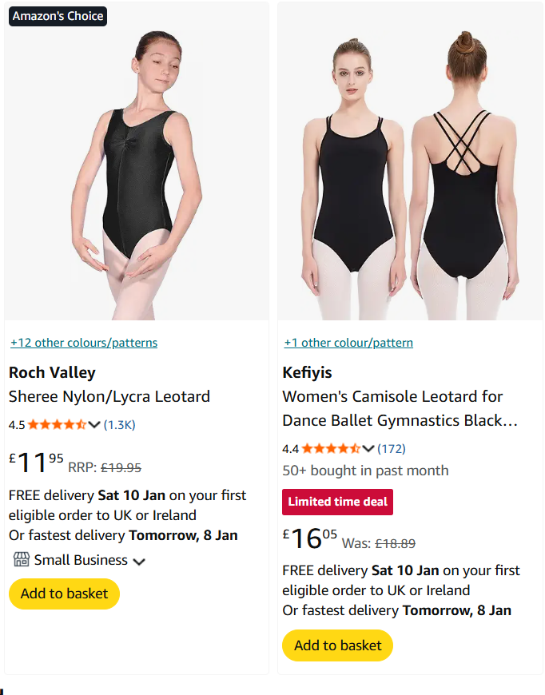
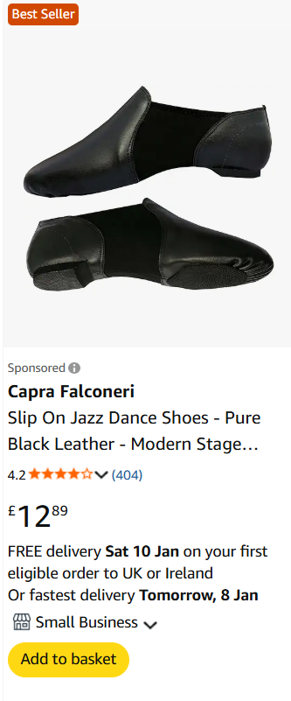

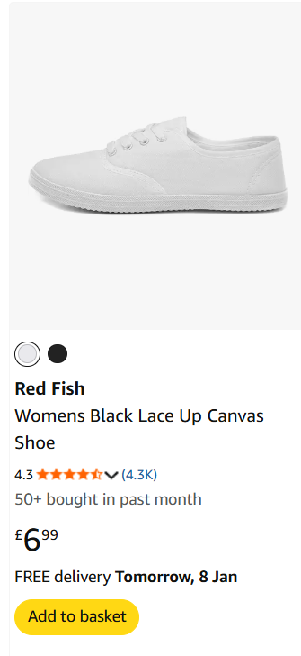

Frat Boy: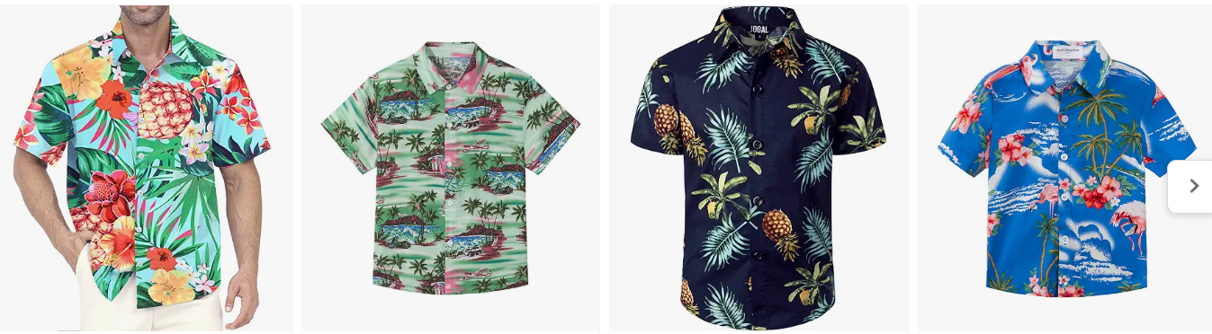
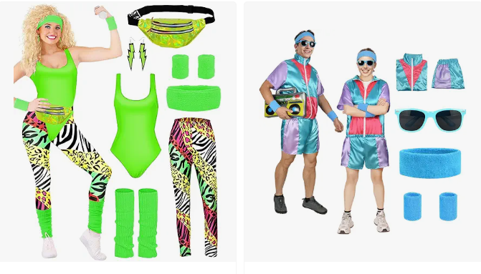
Funky Active Gear:

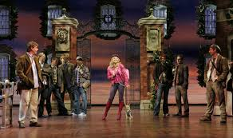
Harvard Uni Students:
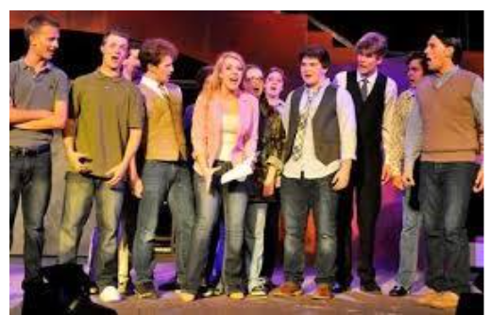
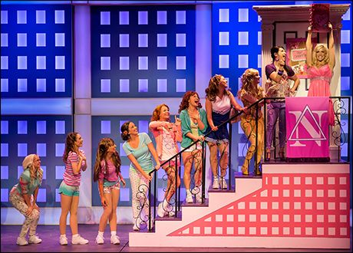
Delta Nu Ensemble:

SALESWOMAN
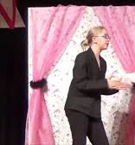

VIVIENNE
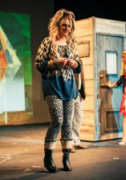
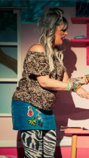
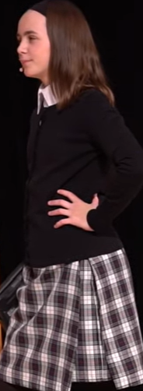

PAULETTE

SALESWOMAN
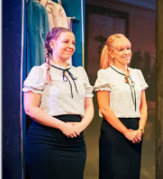

KATE
