ACADEMIC YEAR 2025/2026
SCHOOL DAY

8:40 am Arrival for students
8:45 am Tutor Time
8:55 am Reading
9:15 am Lesson 1

10:15 am Lesson 2 – (with 2 x 20 minute breaks)

Break | 10:15 - 10:35 am | Yr7, 11 and 8X
Break | 11:15 - 11:35 am | Yr9, 10 and 8Y

11:35 am Lesson 3

12:35 pm Lesson 4 - (with 2 x 35 minute lunches)

Lunch | 12:35 - 1:10 pm | Yr7, 11 and 8X
Lunch | 1:35 - 2:10 pm | Yr9, 10 and 8Y

2:10 pm Lesson 5
3:10 pm End of Day

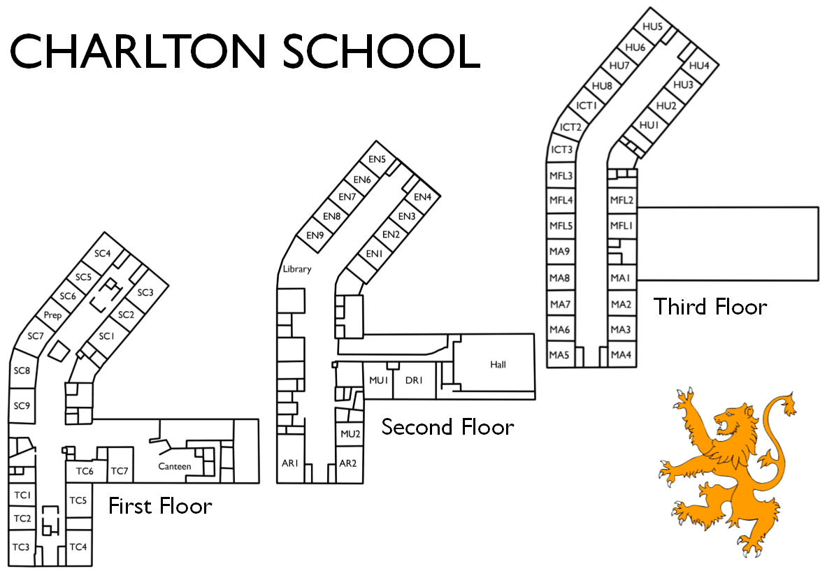
Prayer Room

Term Dates 2025 - 2026

Autumn Term 2025
PD Days Monday 1st September and Tuesday 2nd September
Term Starts Wednesday 3rd September
Half Term 27th October - 31st October
Term Ends Friday 19th December

Spring Term 2026
PD Day Monday 5th January
Term Starts Tuesday 6th January
Half Term 16th - 20th February
Term Ends Friday 27th March

Summer Term 2026
PD Day Monday 13th April
Term Starts Tuesday 14th April
May Bank Holiday Monday 4th May
Half Term 25th - 29th May
Term Ends Friday 17th July

