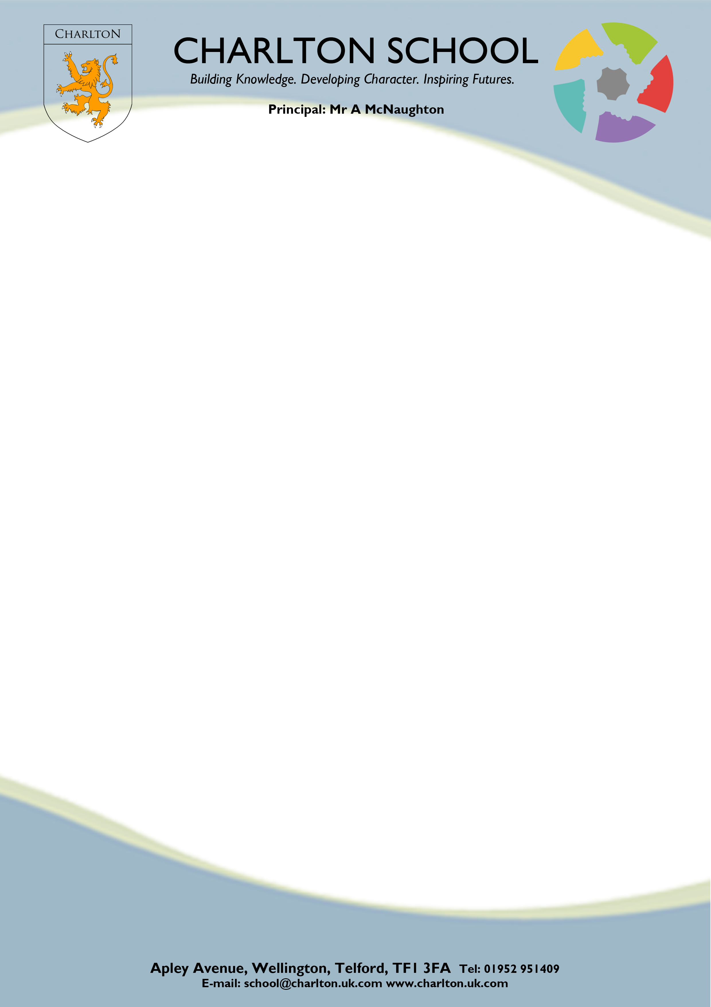

Dear Parent/Carer,

Year 7 Induction and Team Building Programme

We have arranged to take our Year 7 students on a residential activity course to the PGL Boreatton Park, leaving on Wednesday 12th November and returning on Friday 14th November. Fully trained and qualified instructors will provide instruction in a programme of activities in a safe, controlled and secure environment.

The students will take part in nine activities, which are likely to include those listed below:

- Abseiling | - Initiative Games | - Zip Wire
- High ropes | - Climbing
- Archery | - Raft Building
- Challenge Course | - Raft Building

These activities are very much aimed at providing fun and adventure for the children while, at the same time, enhancing the development of their personal and social skills. However, we have also tried to cater for children who prefer less challenging activities. The course is also designed to develop team skills, and the children should benefit enormously from the experience. For these reasons, we feel it is important that as many children as possible take part in the visit.

The cost will be £204.00 and this includes: -

- All equipment and instruction | - 9 activities | - Full board
- Evening activities programme | - Transport | - Insurance

If you wish your child to take part in this visit, please sign and return the reply slip along with a non-returnable deposit of £80 (please pay by cheque if possible; cheques to be made payable to Charlton School, putting your address and your child’s name on the back) to the Finance Office at Charlton. Alternatively, you may pay during the Transition Parents’ Evening on Monday 7th July. Please could you complete and return the attached Consent Form at the same time.

You may wish to pay the full amount straightaway, but for those of you who wish to pay in instalments, we have set up the following payment dates to help spread the payments for you:

By Monday 7th July - Initial deposit of £80 (to the Charlton Finance Office or pay during the Transition Parents’ Evening)
Friday 5th September - Second Payment of £64
Friday 17th October - Final payment of £60 (to the Finance Office at Charlton)

The final balance must be paid by Friday 17th October.

We do not wish to exclude any child from the trip on the grounds of affordability. If your child is in receipt of free school meals, please contact Mrs Hughes and we may be able to arrange a subsidy.

Yours faithfully,

Mr Redman
Assistant Vice Principal – Student Engagement

Note : Recent national court action against teachers acting in good faith as responsible parents on a school trip have necessitated a review of our current policy on what is a sensible response to bad behaviour or non-compliance. We will operate a policy of zero tolerance on any behaviour which is deemed to be unacceptable or which could prove dangerous to another person. In either of these cases, the student or students concerned will be returned home at short notice. Parents or a trusted friend or relative must be available at any time to collect the returned student and provide a home for them for the duration of the trip. Clearly, contact numbers must be available for this purpose.

NOVEMBER 2025 : Year 7 Induction and Team Building Programme – PGL boreatton Park

Name of Student: …………………………………………………………………………….…………. Form: ………..…….

I give my permission for my child to take part in the residential visit to Boreatton Park. I enclose a
non-returnable deposit of £80 and the completed consent form.

Signed: ……………………………………………………………………….………….. Parent/Carer Date: ……………………..

The school reserves the right to refuse to allow a student on this visit if their behaviour in school prior to departure falls below acceptable standards. If such unsatisfactory behaviour occurs and action, as outlined above, has to be taken, it is likely that monies paid will have to be forfeited. Any student behaving in an unacceptable manner during the visit will have to be collected from the Pioneer Centre by the parents.

Please return to the Charlton Finance Office along with the Parental Consent Form.

