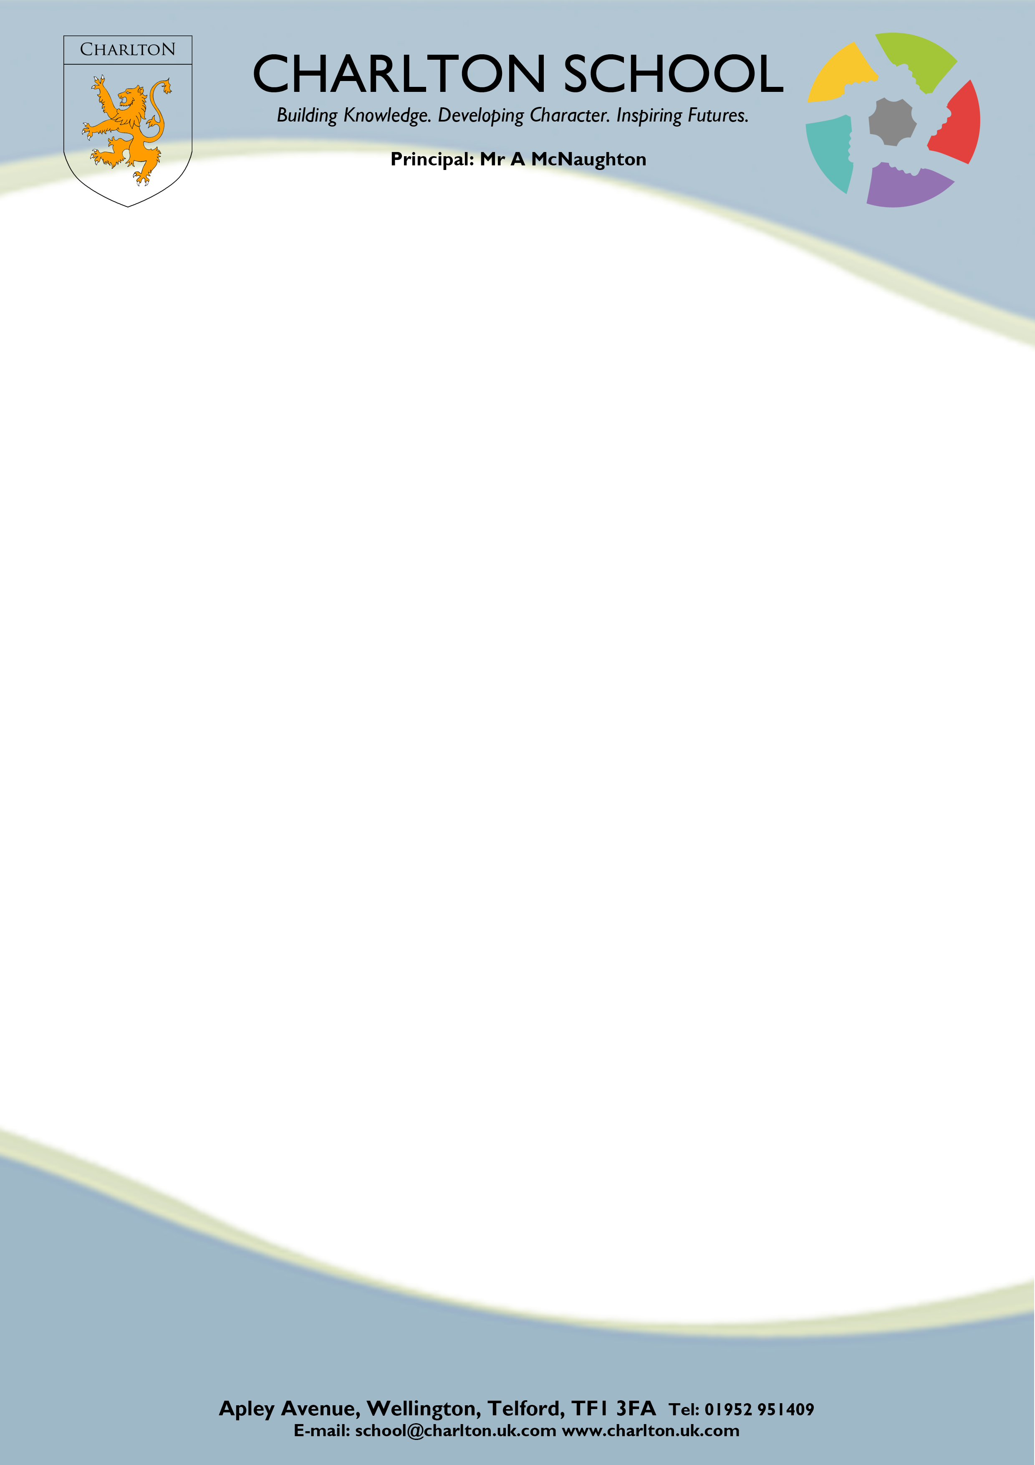

April 2025

Dear Parent/Carer,

Charlton School wishes to use information about your child as part of any automated recognition system. This is for the purposes of our cashless catering. The information from your child that we wish to use is referred to as ‘biometric information’. Under the Protection of Freedoms Act 2013 (sections 26 and 28), we are required to notify each parent of a child and obtain the written consent of at least one parent before being able to use a child’s biometric information for an automated system.

Biometric information and how it will be used
Biometric information is information about a person’s physical or behavioural characteristics that can be used to identify them, for example, information from their finger or thumb print. The school would like to take and use information from your child’s thumb and use this information for the purpose of providing your child with access to our cashless catering system.

The information will be used as part of an automated biometric recognition system. This system will take measurements of your child’s thumb and convert these measurements into a template to be stored on the system. An image of your child’s thumb is NOT stored. The template (i.e. measurements taken from your child’s thumb is what will be used to permit your child to access the service.

If your child already has had a biometric measurement of their thumb, we still require you to complete the authorisation again, thank you.

You should note that the law places specific requirements on schools when using personal information, such as biometric information, about pupils for the purposes of an automated biometric recognition system.

For example:

- The school cannot use the information for any other purpose other than those for which it was originally obtained and made known to the parents, (i.e as stated above).
- The school must ensure that the information is stored securely
- The school must tell you what it intends to do with the information
- Unless the law allows it, the school cannot disclose personal information to another person/body

Providing your consent or objection
As stated, in order to be able to use your child’s biometric information, the written consent of at least one parent is required. However, consent given by one parent will be overridden if the other parent objects in writing to the use of their child’s biometric information. Similarly, if your child objects to this, the school cannot collect or use his/her biometric information for inclusion on the automated recognition system.

You can also object to the proposed processing of your child’s biometric information at a later stage or withdraw any consent you have previously given. This means that, if your give consent but later change your mind, you can withdraw this consent. Please note that any consent, withdrawal or consent or objections from a parent MUST be in writing.

Even if you have consented, your child can object or refuse at any time to their biometric information being taken or used. His or her objection does NOT need to be in writing. We would appreciate if you could discuss this with your child and explain to them that they can object to this if they wish.

The school is also happy to answer any questions you or your child may have.

If you do not wish your child’s biometric information to be processed by the school, or your child objects to such processing, the law says that we must provide reasonable alternative arrangements for children who are not going to use the automated system to access the cashless catering system.

If you give consent to the processing of your child’s biometric information, please sign, date and return the attached consent form to the school.

Please note that when your child leaves the school, or if for some other reason he/she ceases to use the biometric system, his/her biometric data will be securely deleted.

Further information and guidance

This can be found via the following link:

Department for Education’s ‘Protection of Biometric Information of Children in Schools – Advice for proprietors, governing bodies, head teachers, principals and school staff.’

https://www.gov.uk/government/publications/protection-of-biometric-information-of-children-in-schools

CONSENT FORM FOR THE USE OF BIOMETRIC INFORMATION IN SCHOOL
Please complete this form if you consent to the school taking and using the information from your child’s thumb print by Charlton School as part of an automated biometric recognition system. This biometric information will be used by Charlton School for the purpose of access to our cashless catering system.

In signing this form, you are authorising the school to use your child’s biometric information for this purpose until he or she leaves the school or ceases to access the system. If you wish to withdraw your consent at any time, this must be done so in writing and sent to the school at the following address:

Miss H Smith
c/o Charlton School
Apley Avenue
Wellington
Telford TF1 3FA

Once your child ceases to use the biometric recognition system, his or her biometric information will be securely deleted by the school.

If you have any questions regarding any of the above, please do not hesitate to contact me on 01952 386800.

Yours sincerely,
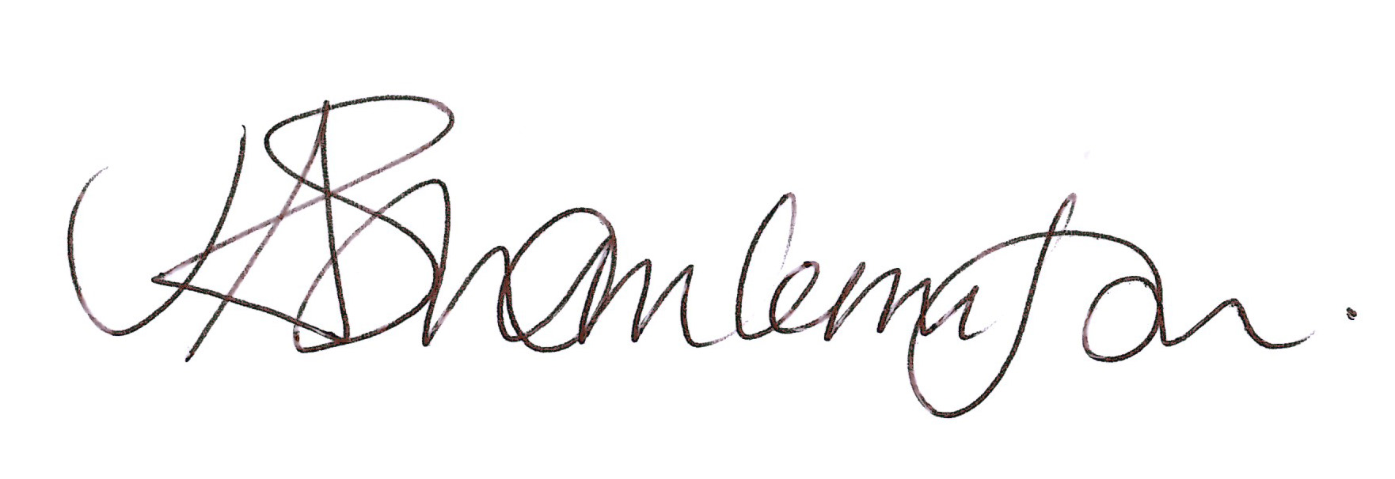
J A Thomas-Clemson
Operations Manager

Biometric Information

Having read the guidance provided to me by Charlton School, I give consent to information from the thumb print of my child being taken and used by Charlton School for use as part of any automated biometric recognition system for accessing the cashless catering or library system, for which this data will be used.

I understand that I can withdraw this consent at any time in writing.

Name of Parent / Carer ___________________________________________________________________

Signature of Parent / Carer ____________________________________________________________

Student Name ______________________________________________________________________

Date ________________________________

Please return this form for the attention of Miss H Smith, Student Support Manager.

