ACADEMIC YEAR 2024/2025
PROVISIONAL SCHOOL DAY

8:40 am Arrival for students
8:45 am Tutor Time
8:55 am Reading
9:15 am Lesson 1

10:15 am Lesson 2 – (with 2 x 20 minute breaks)

Break | 10:15 - 10:35 am | Yr7, 11 and 8X
Break | 11:15 - 11:35 am | Yr9, 10 and 8Y

11:35 am Lesson 3

12:35 pm Lesson 4 - (with 2 x 35 minute lunches)

Lunch | 12:35 - 1:10 pm | Yr7, 11 and 8X
Lunch | 1:35 - 2:10 pm | Yr9, 10 and 8Y

2:10 pm Lesson 5
3:10 pm End of Day

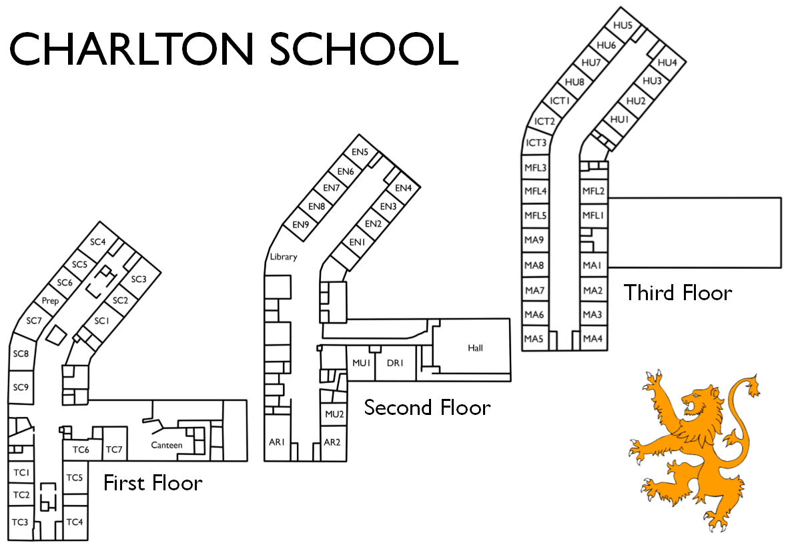
Prayer Room

Term Dates 2024 - 2025

Autumn Term 2024
PD Day Tuesday 3rd September
Term Starts Wednesday 4th September
Half Term 28th October - 1st November
Term Ends Friday 20th December

Spring Term 2025
PD Day Monday 6th January
Term Starts Tuesday 7th January
Half Term 17th - 21st February
Term Ends Friday 11th April

Summer Term 2025
Term Starts Monday 28th April
May Bank Holiday Monday 5th May
Half Term 26th - 30th May
Term Ends Thursday 17th July
PD Day Friday 18th July

