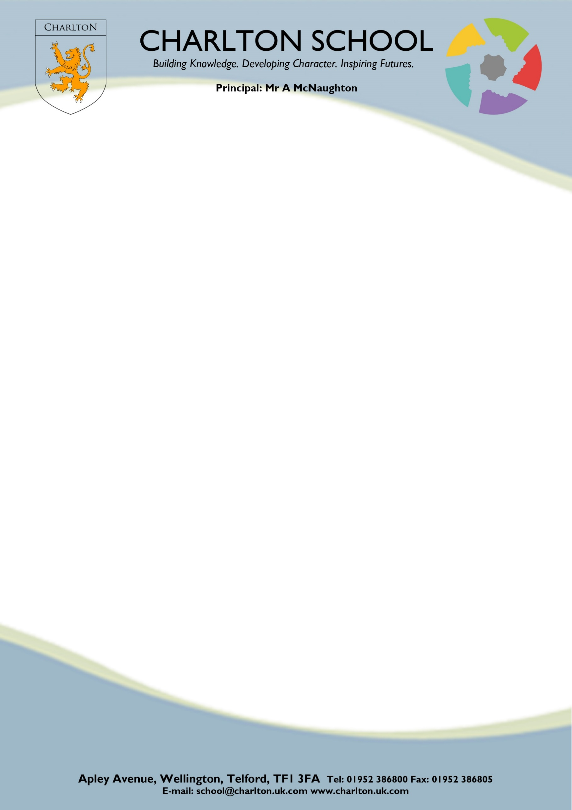

April 2023
Student data admission form
and home school agreement

Why are we collecting your child’s personal data and what will we do with it?
Charlton School are collecting your child’s data to enable the school to register your child with the school to comply with a legal requirement under the Education (Pupil Registration) (England) Regulations.

Your child’s personal information will be processed in accordance with the requirements of the Data Protection Act 2018 and will only be shared with 3rd parties where we are required / allowed to do so by law. Please note minimal amounts of your child’s personal data will be securely shared with Telford and Wrekin Council and the DFE in compliance with the regulations stated above.

To learn more about what personal data the school collect, why it collects and who it might share it with please view our privacy notice on the school website.

*Please note it is the parents/carers responsibility to notify the school immediately if any of the information on this admission form changes*

Legal Surname |  |  | Legal First Name
Middle Name (s) |  |  | Preferred Name
Address of Student |  |  | Gender
Address of Student |  |  | Home Telephone No.
Address of Student |  |  | Date of Birth
Post Code

E-Mail Contact – The schools intranet gives parents access to their child’s assessment details online. For access you are asked to submit an e-mail address which will be your username. You will then be issued with a password. Please identify below your e-mail address that will be used for your account name.

Please write in Block Capitals

Previous School

Parental Responsibility - Please give details of all persons who have parental responsibility.

Preferred Title/Name/Relationship | Home Address / Phone No. / Mobile No  / E-mail Address | Day Address / Phone No. / Mobile No

Emergency Contacts - Please list below in order of priority the names, addresses and telephone numbers of 3 people for us to contact in case of an emergency. These may of course be parents.

 | Name / Relationship | Home Address / Phone No. / Mobile no. | Day Address / Phone No. / Mobile No.
1
2
3

Second Parents – A second parent i.e., a divorced or separated parent who is not living with the child, is entitled to receive copies of all school correspondence. Please complete the box below.
Please note unless a sole custody arrangement is in place all second parents are entitled to receive information.

Parent Name
Address & Email

Siblings – Please list all siblings and which schools they attend.

Sibling Name | School
YES
NO
Free School Meals – Is your child entitled to Free School Meals?

Service Children - Are you are a parent serving in regular HM Forces military units, or in the Armed Forces of another nation and stationed in England? The school can claim additional funding for children of Service Personnel.
YES
NO

Disability Discrimination Act – This act states that a person is ‘disabled’ if they have ‘a physical or mental impairment which has a substantial and long term (likely to last more than 12 months) adverse effect on his/her ability to carry out normal day to day activities’. If your child is affected by a disability, please provide details below. You may also wish to outline details about family members at home with a disability that may impact on your child’s education.

Special Education Needs - To enable us to provide the correct level of support for your child it is important.
you complete the following.

Is your child on the Special Educational Needs (SEN) register? YES NO

If YES, please tick which level.

EHC - Education, Health and Care (E) SEN Support (K)

If you have any questions whilst completing this section, please contact the school SENCO.

Ethnicity - We are required by the Department for Children Schools and Families to return this information on an annual basis via the School Census - Please tick one box only:-

White British (WBRI) |  |  | Indian (AIND)
White Other European (WEUR) |  |  | Mirpuri PAKISTANI (AMPK)
White Irish (WIRI) |  |  | Other PAKISTANI (AOPK)
Gypsy / Roma (WROM) |  |  | Bangladeshi (ABAN)
Any Other White Background (WOTH) |  |  | Any Other Asian Background (AOTH)
 |  |  | Chinese (CHNE)
White & Black Caribbean (MWBC)
White & Black African (MWBA) |  |  | Caribbean (BCRB)
White & Asian (MWAS) |  |  | African (BAFR)
Any Other Mixed Background (MOTH) |  |  | Any Other Black Background (BOTH)
Any other Ethnic Group not listed above. Please state ________________________________________________

I do not wish an ethnic background category to be recorded (REFU)

Religion ____________________________________________________________ * Optional

Language - If your child regularly speaks another language at home please complete the box below.

First Language |  | Second Language
Any other language |  | Language spoken by adults at home

Parental Permissions

Please indicate whether you have given your consent in each case by ticking the box on the right-hand side against each statement below. If in future you wish to remove your consent for any of the actions below you can do so by contacting the school office.

 | YES | NO
Local Visits I give consent for my child to take part in normal school activities organised to take place outside the school premises .i.e. to Wellington, Dothill, Apley Woods, local primary schools, local colleges etc.

After School Clubs / Activities
If your child is in a sports team / choir / orchestra / drama production etc. there will be a commitment on your behalf that he/she is collected from school at the pre-arranged time. The school will issue written times for rehearsals / matches etc; and the student is responsible for giving this information to his/her parents/carers.

Internet Access
I have read and understood the Student Code of Conduct for Network and Internet Use and give my permission for my child to access the Internet. I understand that the school will take all reasonable precautions to ensure students cannot access inappropriate materials. I understand that the school cannot be held responsible for the nature or content of materials accessed through the Internet. I agree that the school is not liable for any damages arising from use of the Internet facilities.

Web Publication of Work
I give my permission that, if selected, my child’s work may be published on the school website. This also includes social media sites such as Facebook or Twitter.

Biometric Data
I give permission for my child’s fingerprint to be used to access their personal account in the school canteen. I understand that my child’s fingerprint will be measured and a template created. An actual image of the thumbprint is NOT stored. It cannot be accessed by anybody outside of the school.

Medical Matters

I give my permission for my son/daughter: | YES | NO
To be given first aid by a trained member of staff during any on-site or off-site activity

In the event that your son/daughter requires emergency/lifesaving medical treatment, trained school staff will liaise with emergency services to ensure treatment can be given. We will make every effort to obtain your agreement for this prior to any arrangements being actioned.

Use of Name/Image (Including photographs and video recordings)

I give my permission for my son/daughters: | YES | NO
Name to be used on the school website, printed publications and media (Could be viewed by external parties and potentially worldwide)
Image to be used on school website and/or media
Image to be used within school, e.g. on school books, wall displays, etc.
Image to be used in printed school publications, e.g. school prospectus, newsletters, etc.
Image to be taken and used for miscellaneous circulation, e.g. images taken at school events.
Image to be displayed in non-public positions (staff room, school office, etc.) if child has a medical condition/allergy that a member of staff needs to be aware of.

Signed ________________________________________________ Date ____________________
Parent / Carer

Parental Access of Student Data – Code of Conduct
Rules for Parents / Carers

The computer system is owned by the school. This Responsible Parental Use statement helps to protect students, staff and the school by clearly stating what is acceptable and what is not.

- Parents / Carers will be given access to data that the school holds pertaining to their children and only their children where the law allows.
- Usernames used by parents/carers to access this data will be their e-mail addresses. If this email address is changed then the parent/carer must notify the School in writing.
- Passwords, which are used for access, will be emailed directly to the parent/carer by the School.
- Network access must be made via the parents/carers authorised account and password, which must not be given to any other person including their children. The password supplied by the School must be kept secret from all other parties.
- If parents/carers believe that their unique password is known by any other person then they must notify the school immediately and another password will be issued.
- If it becomes apparent that a parents/carers username and/or password is being used by someone other than the person they were issued to, the School has the right to revoke the parent’s access to the School network.
- School system security must be respected; it is a criminal offence to use a computer for a purpose not permitted by the system owner.
- Copyright and intellectual property rights must be respected.
- The school may exercise its right to monitor the use of the school’s computer system, including the deletion of data, where it believes unauthorised use of the school’s computer system is or may be taking place, or the system is or may be used for criminal purposes or for storing unauthorised or unlawful imagery.
- In accordance with the Data Protection Act (2018), data held on teachers/students must only be used for specific purposes allowed by law. Teacher and students, as data subjects, have certain rights under the Act, including a general right of access or personal data held on them, with parents exercising this right on behalf of students, where applicable.

Signed ________________________________________________ Date ____________________
Parent / Carer

Student code of Conduct for
Network and internet use

School must make sure that students work legally and are safe using computers. For these reasons it is important the student signs and agrees to the following:

- You must not access inappropriate web sites (‘inappropriate’ means not sanctioned by a teacher, sexually explicit, violent etc.).
- All IT devices should be treated with respect, any damage must be reported to the teacher immediately. Any laptops removed from a cabinet/trolley should be returned to the same cabinet in the correct numbered tray (where applicable) and placed on charge. Each time you login you will be prompted to accept the AUP (Acceptable Usage Policy). This is subject to change and if you do not agree to the terms listed you will be logged out of the system.
- Access is limited to the user’s authorised account and password which must not be shared. When leaving a workstation for any period, it must be locked with Win+L or by pressing CTRL+ALT+DEL and clicking ‘Lock’ to prevent unauthorised access.
- Personal data must not be left unsecured on the device at any time. This includes copying the data to the local hard drive which is for temporary storage only in the event the network is inaccessible.
- Caution should be exercised before giving out any personal details or information about the school over the network.
- The network and internet must only be used for educational purposes. Any doubt as to what constitutes educational use should be referred to the Principal.
- All of your files must be stored in your own folder on the ‘U’ drive and OneDrive. The only exception to this is when a teacher requires you to save files to a shared drive (Student IN).
- Any attempts to access unauthorised materials or bypass security systems constitutes a breach of the Computer Misuse Act (1990) and will result in disciplinary action.
- Your work should be your own. Anything you download should be acknowledged for copyright.
- E-mails should be typed only as part of a school activity and should be polite, non-threatening and only to allowed contacts using the school system.
- You are responsible for any messages you send and for contacts made. Any messages should be written responsibly and politely. Abuse of any kind is forbidden.
- Use of chat rooms, message boards and chain emails are not allowed unless part of a subject provision.
- If you receive any unpleasant or inappropriate content, it should be reported to ICT.
- You could be acting illegally if you do anything on a computer that is not allowed. This includes downloading software, games or other material, and uploading photos from mobile phones etc. You must be aware of copyright and intellectual property rights before distributing content or resources.
- Your space on the network is constantly monitored and is restricted. You are responsible for everything in your ‘U’ drive and OneDrive folders and using it exclusively to store schoolwork related materials.

- According to the Data Protection Act (2018), it is illegal for you to access personal information without consent. In the UK, consent to disclose personal information can only be legally provided by those ages 13 and above.
- All printing and copying is tracked and an audit trail is associated with the users authorised account. You will be provided with a PIN code via Email for the MFD Copiers to be able to print schoolwork related materials. Any unauthorised printing or misuse of our printing systems will result in a printing ban. The duration of this is dependent on the cost implications of the offence.

Any breach of any of the above will result in disciplinary action. You may lose access rights to the network and this may seriously affect your education.

The school may exercise its right to monitor the use of all of the school’s computer systems, including access to websites, the interception of e-mail and the deletion of inappropriate materials where it believes unauthorised use of the school’s computer system is taking place. This includes when the system is used for unlawful purposes.

Mobile Phones and other Electronic Devices
If a student is seen or heard with a mobile phone or electronic device it will be confiscated. Parents may be informed that the phone has been confiscated and asked to collect the phone during the school day. The school accepts no responsibility for damage or loss of mobile phones or other items of value such as MP3 players or jewellery whilst on school property. The school policy on mobile phone and electronic devices is available on request.

Signed ________________________________________________ Date ____________________
Student

home school agreEment

Our commitment to you

Our Vision Charlton School: Building Knowledge. Developing Character. Inspiring Futures.
Intent
Our intent is to nurture happy, healthy young people who have the knowledge, academic achievement and strength of character to lead safe and successful lives in modern Britain, preparing them for their next steps in education or employment with a thirst for lifelong learning.
Implementation
- Pastoral care. We ensure that every member of our school community knows that we are committed to supporting their physical health, safety and emotional wellbeing.
- Behaviour. Relationships between staff and students are based on our core values: respect, responsibility and resilience. Clearly stated standards of behaviour are to be upheld by all.
- Belonging. We celebrate our differences and show respect for our community. Students understand and develop their role as active and responsible citizens and are equipped with the skills to challenge discrimination.
- Inclusion. Charlton is an outward facing and globally conscious school. We promote compassion, and advocacy for all members of our school community. We are unwaveringly inclusive and determined to eradicate all barriers to educational success.
- Curriculum. We are committed to delivering a broad, balanced and knowledge rich curriculum to enable all students to achieve their best and be well equipped for the future.
- Co-Curriculum. Our curriculum is enhanced by a wide range of sustained enrichment opportunities, enabling students to discover and nurture their individual talents and interests.
- Facilities. Our new building provides a clean, bright, safe and stimulating learning environment with state-of-the-art equipment.
- Celebrating success. We celebrate success at all levels. Students are encouraged to apply a growth mindset to both their academic and personal progress.
- Partnership. We have well established links with our local community and view partnerships with the Learning Community Trust, wider community partners and our families as central to our success.

Our ethos is built around three core values: Respect, Responsibility and Resilience. We expect all members of the Charlton community to exhibit these values at all times. Underpinning our vision and values are our shared character virtues:
Gratitude: feeling and expressing thanks.
Compassion: exhibiting care and concern for others.
Humility: estimating oneself within reasonable limits.
Justice: acting with fairness towards others by honouring rights and responsibilities.
Courage: acting with bravery in fearful situations.
Integrity: having strong moral principles and standing up for what you believe in.
Honesty: being truthful and sincere.

Charlton actively promotes the fundamental British values of democracy, the rule of law, individual liberty and mutual respect and tolerance of those with different faiths and beliefs.
HOME SCHOOL AGREEMENT

Your commitment to Charlton

Our continual drive to raise standards ensures that students, staff, parents, and carers are clear about the expectations we have of each other and how these support progress for all. We know that good learning only takes place in a safe, secure and well-disciplined environment. Please read the following home school agreement and sign to say that you agree to uphold the standards at the bottom of the form.

Home School Agreement

Students throughout the school and in the community are expected to take responsibility for their own behaviour for learning to meet, and go beyond, the expectations of Respect, Responsibility and Resilience:

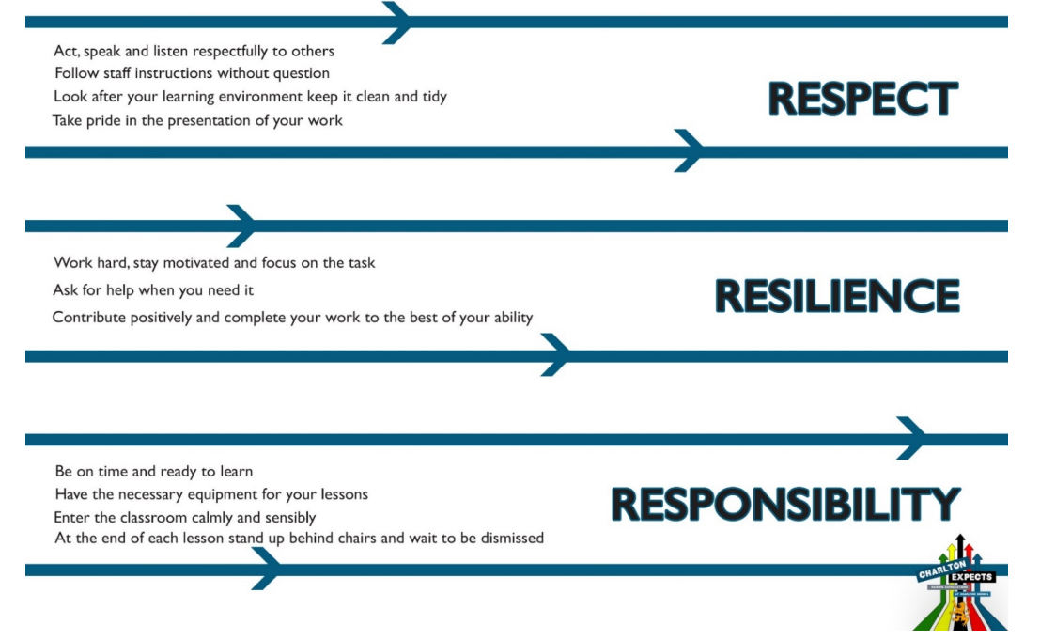

Respect
- Enter and leave the school sensibly
- Act, speak and listen respectfully to others
- Be respectful and polite to other students, staff, visitors and members of the local community
- Follow staff instructions without question
- Look after your learning environment and keep it clean and tidy
- Take pride in the presentation of your work
- Take pride in wearing your uniform correctly; you are an ambassador for Charlton school

Responsibility
- Be on time to lessons and ready to learn
- Ride your bike responsibly on the school site; Do not cycle on the road
- Conduct yourself in a safe and sensible manner when moving through the corridors
- Have the necessary equipment for your lessons
- Enter the classroom calmly and sensibly
- At the end of the lesson stand up behind chairs and wait to be dismissed
- Leave toilet areas clean and tidy
- Don’t drop litter; use bins provided
- No food on the courts or upstairs. You may drink bottled water during lessons, except in areas such as Science labs, Technology, Drama and ICT rooms
- Smoking or vaping is forbidden in or around the school site
- Phones off and away until the end of the day
- No Swearing
- No chewing gum

Resilience
- Work hard, stay motivated and focus on the task
- Ask for help when you need it
- Contribute positively and complete work to the best of your ability

The school reserves the right to take any reasonable action as a result of breaking its rules and regulations by any student, when he/she is on or off site, for example to and from School, content posted on the internet and school trips. This includes taking sanctions up to and including permanent exclusion for students whose actions bring the school into disrepute and/or where there is a link between maintaining good behaviour and discipline among the student body as a whole.

Further details, including a copy of the full Behaviour for Learning Policy can be found on the policies page of the school website: https://www.charlton.uk.com/our-school/academy-policies

We agree to uphold the standards detailed in the Home School Agreement:

Signed ________________________________________________ Date ____________________
Parent / Carer

Signed ________________________________________________ Date ____________________
Student

