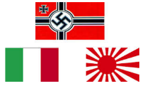
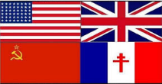
KNOWLEDGE ORGANISER
WORLD WAR II
Main Participating Countries |  |  |  |  |  |  | Major Events
ALLIED POWERS |  |  | AXIS POWERS |  |  |  | Event | Image | Description | Date/s | Fact
Country | Date Joined | Death Toll | Country | Date Joined | Death Toll |  | WWII Begins | 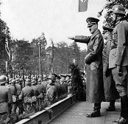 | On 1st September 1939, Germany invaded Poland, utilising the ‘Blitzkrieg’ strategy. Britain and France (Poland’s allies) gave a notice period for the Germans to withdraw their troops from Poland. When they did not, Britain and France declared war on 3rd September. Britain initially responded with bombing raids over Germany. Nearly six years of war in Europe was to follow. | 1st-3rd September 1939 | Hitler claimed to attack Poland to give the German people ‘Lebensraum’ – living space
FRANCE | 3rd Sep, 1939 | 600,000  1.44% of population in 1939 | 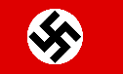  GERMANY | 1st Sep, 1939 | approx.  7,200,000  8.5% of population in 1939
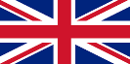  UK | 3rd Sep, 1939 | 450,900  0.94% of population in 1939 | 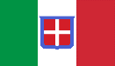  ITALY | 11th Jun, 1940 | approx.  500,000  1.14% of population in 1939 |  | Evacuation of Children | 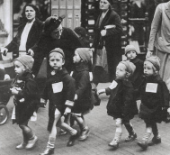 | People expected cities to be bombed, as enemy planes tried to hit targets, for example warehouses and factories. This put would have put city children (in schools and houses close by) in grave danger, and so thousands were evacuated to the countryside. Many were extremely homesick, but some enjoyed their new lives. | September 1939 onwards | About 800,000 children left their homes throughout the war.
SOVIET UNION | 22nd Jun, 1941 | approx. 24,000,000 13.7% of population in 1939 | 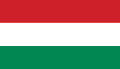  HUNGARY | 27th Jun, 1941 | 464,000  5.08% of population in 1939 |  | The Holocaust | 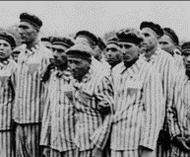 | The Holocaust was a genocide committed by Germany and its allies before and during WWII. It involved the systematic murder of 6 million Jews, and millions of ‘undesirable’ others (around 9-12 million in total). Many were gassed, starved, or died of disease in concentration camps. Conditions in the camps diabolical. | 1933-1945 | During the Holocaust, about two thirds of the Jews in Europe were killed.
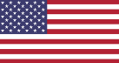  USA | 8th Dec, 1941 | 419,400  0.32% of population in 1939 | JAPAN | 7th Dec, 1941 | approx.  3,000,000  4.1% of population in 1939 |  | Evacuation of Dunkirk | 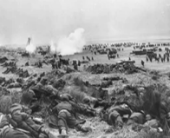 | Large numbers of British, French, and Belgian troops were surrounded by German soldiers at the French coastal town of Dunkirk, and seemed set to perish. Remarkably, 338,226 were saved by a fleet of 800 small boats. The event is also known as the ‘Miracle of Dunkirk.’ | 26th May – 4th June 1940 | Mary was the first queen to rule England in her own right.
 |  |  |  |  |  |  | Battle of Britain | 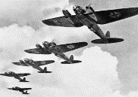 | In the Battle of Britain, the Royal Air Force (RAF) successfully defended UK against attacks by Nazi Germany’s air force: Luftwaffe. It has been described as the first military campaign fought entirely by air forces. | 10th July – 31st October 1940 | This was seen by many as Germany’s first major defeat in the war.
Key People
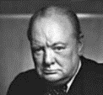  Sir Winston Churchill – (1874-1965) was a British politician who served as the Prime Minister between 1940 and 1945 and again from 1951 to 1955. He took over after a disastrous start to the war in which Nazi Germany conquered much of Europe. He did his best to rally the nation in defiance of Adolf Hitler, possessed excellent military knowledge and forged crucial alliances with both the USA and Russia. Churchill is often characterised for his extraordinary leadership throughout World War II – he was bold, brave, and tireless in his resolve to take on the might of Nazi Germany. |  |  | 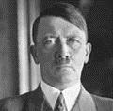  Adolf Hitler – (1889-1945) was a German politician who was the leader of the Nazi party, Chancellor of Germany from 1933-1945, and the Fuhrer of Germany from 1934-1945. In 1923, Hitler had attempted to seize power via a failed coup, and was arrested. However, he began to gain a loyal following through his populist ideas, powerful speeches and charisma. Hitler’s Germany invaded Poland in Sep 1939 to start the war, and he initiated the Holocaust. He is therefore significantly responsible for millions of deaths. He committed suicide on 30th Apr 1945, when the war was clearly lost. |  |  |  | Attack on Pearl Harbor | 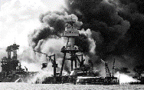 | This was a surprise military attack by Japan on the United States naval base at Pearl Harbor. It led to the US joining the Allies in the war. The attack commenced at 7.48am Hawaiian time, and was carried out by 353 Imperial Japanese aircraft. | 7th December 1941 | 188 aircraft were destroyed and 2,403 Americans were killed.
 |  |  |  |  |  |  | D-Day Landings | 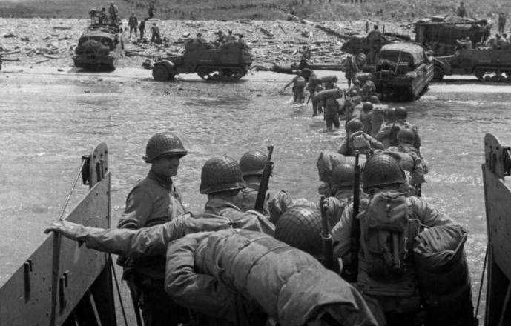 | The Normandy Landings, also known as D-Day, were a series of landing operations by the Allies to claim back Europe. It was the largest seaborne invasion in history. The operation began the liberation of north-western Europe from being under German control. | 6th June 1944 | Between 14,000 and 19,000 men died in the D-Day landings
 |  |  |  |  |  |  | Hitler’s Suicide | 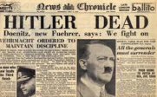 | With the Germans facing defeat, Hitler married his long-time love Eva Braun on 29th April. The next day, they committed suicide, reportedly by gunshot. | 30th April 1945 | There is debate as to how they killed themselves.
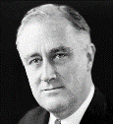  Franklin Roosevelt – (1882-1945) was the 32nd President of the United States, from 1933-1945. Not only did Roosevelt guide the USA through most of World War II, but also the Great Depression – When he took office, nearly a third of America’s workforce were unemployed. Whilst the USA remained officially neutral at the outset of war, Roosevelt offered diplomatic and financial support to the Allies. After the Japanese attacked Pearl Harbor on 7th December 1941, he declared war on the Axis powers. The US greatly helped the Allies to win the war - He died months before it ended. |  |  | 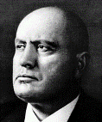  Benito Mussolini – (1883-1845) the leader of Italy’s National Fascist Party. He was Prime Minister from 1922-1945 –from 1925 onwards this was not democratically as he established a dictatorship. Italy entered the war on the side of Germany in 1940, but suffered some disastrous losses. In 1943, Mussolini was dismissed as leader and arrested, but was rescued by Hitler’s paratroopers. He was later put in charge of a puppet regime called the Italian Social Republic, by Hitler. He was later caught by Italian Communist partisans and executed by firing squad in 1945.
 |  |  |  |  |  |  | Germany Surrenders | 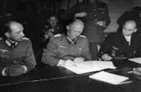 | The Allies had gradually forced the surrender of Axis troops across Europe in April and early May, 1945. On 7th May, Germany officially surrendered to the Allies, bringing to an end the European fighting in World War II. | 7th May 1945 | VE (Victory in Europe) Day is still celebrated on 8th May.
 |  |  |  |  |  |  | America drops the atomic bombs | 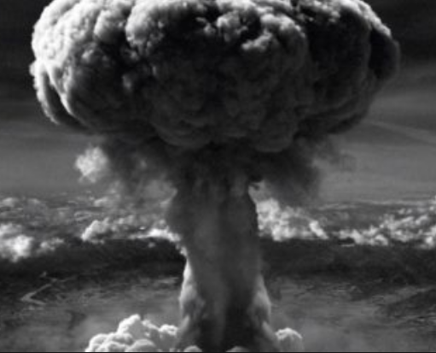 | Japan refused to surrender to the. terms of the Potsdam Declaration in July 1925, pledging to fight onto the bitter end. The US considered an invasion, but would have lost around 500,000 men. Instead, they dropped atomic bombs on Hiroshima (6th Aug) and Nagasaki (9th Aug). | 6th-9th August 1945 | It is thought that 135,000 people died in Hiroshima and 70,000 in Nagasaki.
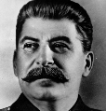  Joseph Stalin – (1878-1953) was the Communist leader/ dictator of the USSR during WWII. After the death of the Communist Leader Lenin, Stalin won a vicious grapple for power before eventually establishing himself as a totalitarian dictator. His own policies became known as ‘Stalinism.’ He had signed a non-aggression pact with Germany in August 1939, but in June 1941, Hitler broke it and the Germans invaded. Although initially suffering heavy losses, the USSR’s key victories in pushing the Germans back signalled a shift in the war in favour of the Allies. |  |  | 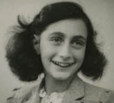  Anne Frank – (1929-1945) was a German-born diarist. As a young Jewish girl, her family were forced into hiding, fleeing Germany for a secret attic in Amsterdam in the Netherlands. She wrote a diary of her time there. After years in hiding, her family was betrayed and arrested, and taken to concentration camps. Anne died of Typhus in Bergen-Belsen concentration camp. The only survivor from her family was Otto, her father, who published her diaries after her death. It has now become one of the most famous and well-read texts in contemporary history.
 |  |  |  |  |  |  | WWII Ends | 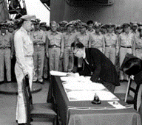 | The surrender of Japan was announced on August 15th 1945. On August 1928, the Occupation of Japan, led by the Supreme Commander for Allied Powers, began. Japan formally signed for surrender on 2nd September 1945, aboard the US Navy battleship USS Missouri. Allied civilians and military celebrated the end of war. The use of atomic bombs to force the surrender is still debated. | 2nd September 1945 | Some rogue Japanese soldiers and pilots refused to surrender even into the 1970s!

4 Jun 1942 – Battle of Midway. US beats Japan
7-8 Dec 1941 – Japan attack US. US joins Allies
22 Jun 1941 – The Axis attack Russia
Jul-Oct 1941 – The Battle of Britain
3 Sep 1943 –Italy surrenders
6 June 1944 – D-Day – allies invade Normandy
25 Aug 1944 – Paris liberated from German control
7 May 1945 – Germany surrenders
Aug 1945 – The US drops atomic bombs on Japan
2 Sep 1945 – Japan surrenders – WWII is over.
May-Jun 1940 – Germany takes over most of Western Europe
Apr-Jun 1940 – Germany invades Denmark and Norway
1 Sep, 1939 – Germany invades Poland - WWII begins
Timeline of Major Events

