KNOWLEDGE ORGANISER
The Suffragists and Suffragettes  The Suffragists |  |  | Answers to Important Questions and Key Vocabulary  The SUFFRAGE MOVEMENT
The Suffragetes  Official Name – The Women’s Social and Political Union  Year formed – 1903  Founding member – Emmeline Pankhurst  How to get the vote – The Suffragettes believed that violence was the only way to achieve the vote.  Tactics used – Chaining themselves to fences, smashing windows, shouting at members of Parliament, blowing up postboxes  Interesting Facts: They had a newspaper called Votes for women and it sold 20,000 copies a week! | Official Name – National Union of Women’s suffrage Societies  Year formed – 1897  Founding member – Millicent Fawcett  How to get the vote – The Suffragists believed that using peaceful tactics would gain them the vote  Tactics used – Writing letters to members of parliament, speaking to MPs, creating petitions, handing out leaflets  Interesting Facts: Initially the suffragists only wanted middle-class women to gain the vote! |  | Why weren’t women allowed to vote? | 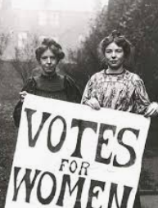 | -Throughout history in Britain (as in lots of countries) a system of patriarchy was in place, meaning that men held far more rights and power than women.  -For example, until fairly recently in history, women were not allowed to go to school, work in certain jobs, or fight in the army.  -Some people falsely believed that men were in some way more intelligent or courageous than women.  -When the movement started, even some women didn’t think that they should be allowed to vote!
 |  |  | What changed in World War I? | 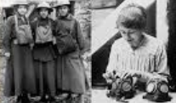 | -When men went away to fight in World War I, women had to take their positions in workplaces.  -Women kept the country running, and this made leaders understand their strength and intelligence.
 |  |  | How did the Suffragette Movement protest? | 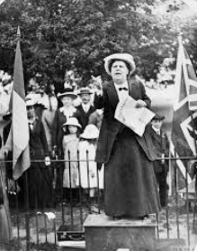 | -The Suffragette movement started off with peaceful protest. They would chain themselves to places, hold up placards, and make speeches about equality.  -However, after they were not being listened to, the protests became more violent.  -There were reports of property damage, physical assaults, and even arson.
Key Moments in the fight for Suffrage
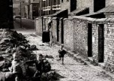  Black Friday  - In 1910 Parliament voted against giving women the right to vote!  - 300 women waited outside Parliament to hear about the outcome of the vote  - Some women were angry at the decision and attacked the police  - Women were attacked by the police!  . | 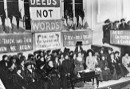  The Epson Darby  - On June 4th, 1913, the annual horse race at Epson Darby took place  - A young suffragette wanted to protest how women were being treated  - Emily Davison tried to place a ribbon on the king’s horse!  - Emily was hit by the King’s horse and later died! |  | How is Emmeline Pankhurst remembered now? | 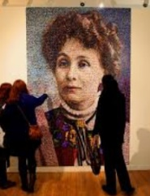 | -After Emmeline Pankhurst died, her former partners in the WSPU mourned her for weeks.  -Newspapers across the world wrote articles about Pankhurst’s impact on equality.  -The year after Pankhurst died, a portrait of her was put up in the National Portrait Gallery.  -We are grateful today that women across Britain are allowed to vote.
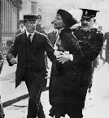
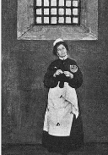
World War One and Women

-During World War One many men went to fight in France
- This left many jobs vacant and a need for goods to be made
- Women up and down the country joined jobs that helped the UK to win the war
- Without the help of women the UK would have lost the First World War

 |  |  | Key Vocabulary
Suffragette
Political
Election
Suffrage
Equality
Prison
Vote
Discrimination
Arrest
Movement
Protest

1928: All women and men aged over 21 were given the vote!
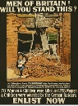  Getting the Vote  - After the amazing work of women during the First World War people decided time for change was needed!  - The British parliament voted that women would be granted the right to vote!  - In 1918 the Representation of the People’s Act was passed allowing all women over the age of 30 the vote (They had to own a house)  - Finally in 1928 women aged over 21 were also granted the right to vote | 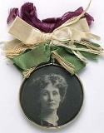  The Cat and Mouse Act  - An act of Parliament allowed women to be arrested and placed in prison  - When in prison these women would go on hunger strike and then would initially force fed  - Women would be released from prison and sent home  - After getting better these women would be rearrested!

1918: Women over 30 were granted the right to vote.
1918: The First World War ends.
1917: The Women’s Land Army was formed
1914: Britain declares war on Germany
1913: The Epson Darby Incident
1910: Black Friday
1866: Manchester becomes the centre of the women’s rights movement.
1903: The WSPU was formed
The Suffrage Movement Timeline
1897: The NUWSS was formed.

