Industrial Revolution
KNOWLEDGE ORGANISER
Spot the Difference between the time periods before and after the Industrial Revolution |  |  | Key events during the Industrial Revolution
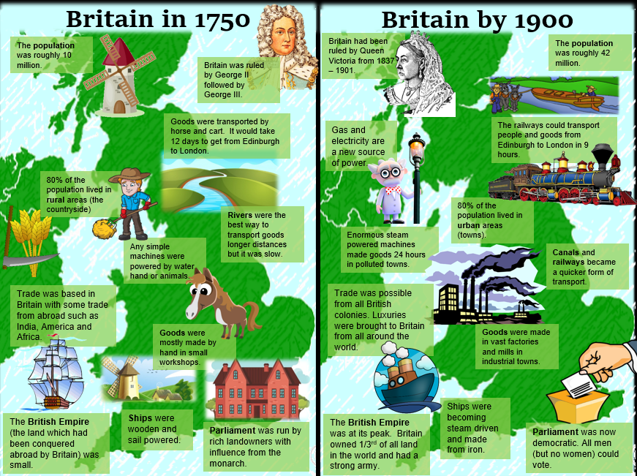 |  |  | Causes of the I.R |  | There are many causes for the Industrial Revolution:  Population growth created a bigger workforce, the empire provided raw materials to make products and sell them, greater transport allowed products to be exported and imported, key individuals like Richard Arkwright for creating the first factory system and many more. | .
 |  |  | Population shift |  | As part of the I.R many people left their homes in the countryside and work as farm laborer’s to work in factories in the cities. The population in Birmingham rose from 30,000 in 1751 to 233,000 by 1851 due to the amount of factories and jobs that were created there.
 |  |  | STEAM! |  | In 1768 Scottish inventor developed a new type of Steam Engine that would turn a wheel to produce steam and power machinery. This then enabled factories like the ones Richard Arkwright opened in Sheffield to use this steam engine and water wheels to power the cotton mills.
 |  |  | Child Labour | 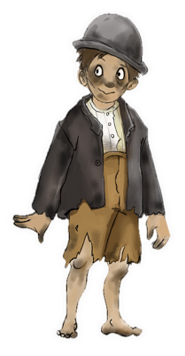 | For Britain to become as wealthy as they hoped during the Industrial Revolution, they needed to exploit those less off and Children were one of them. Many children, living with family or in orphanages were made to work for very low wages in dangerous conditions in the factories to produce cotton for clothes. Children were also sent down the mines to mine coal to power steam engines. Their lives were very difficult and many were left scarred, with injuries or dead due to the work they had to do.  Although it wasn’t just children that were exploited, many people all around the world in the British Empire were exploited for Britain’s wealth to gain resources abroad and people were even used as slaves!
 |  |  | Reforms |  | From 1833 the Government started to make changes to working conditions in Britain realising the negative impact Industry was having on the working class. In 1833 no children under 9 could work in a factory; in 1842 no children under 10 could work down a mine; in 1844 women could not work longer than 12 hours per day and this was reduced to 10 hours in 1847. In 1871 Trade unions were introduced to give workers more rights and in 1895 no children under 13 could work in a factory.
Famous Entrepreneurs during the Industrial Revolution
Richard Arkwright  Richard Arkwright created a machine called the spinning frame in 1769, it could produce strong thread quickly but it was too big to fit into peoples homes. For this reason working from home was replaced with large buildings called factories that people could work in together to make products quicker and cheaper. | James Watt  Was born in Scotland in 1736 and is responsible for creating one of the first steam engines that revolutions the way power could be used in factories but also for transport e.g. steam trains and ships. His invention was inspired by a kettle boiling water to create steam. |  | Inventions | 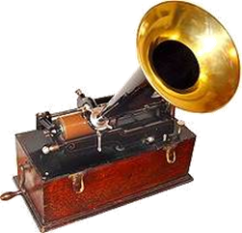 | The first permanent photograph was taken by Frenchman Joseph Niépce in 1816! It simply showed the view from his window.  In 1849, an Englishman called Charles Babbage designed what he called the ‘Difference Engine’. It could ‘compute’ mathematical sums (like a calculator).  The first car with a petrol engine was invented by a Belgian man called Lenoir in 1863.  Alexander Graham Bell in 1876 to invent the telephone.  In 1877, an American named Thomas Edison invented a machine that he called the ‘phonograph.  In 1880 however, the first refrigerator for frozen meat was used to bring over frozen meat from Australia and then beef from Argentina  The first bicycle to be chain powered and have equal sized wheels was made in Britain in 1885.  In 1885, sewing machine company Singer created the ‘New family sewing machine’ went on sale to the public.  The first typewriter available for businesses and individuals to buy was in 1874. Before this, everything that was written had to be written by hand. They were in most offices by the 1880s.
Stephenson and Brunel  George Stephenson and Isambard Brunel and key engineers responsible for modernizing transport during the Industrial Revolution. Stephenson was given the nickname the father or the railway due to the steam engine train network between Birmingham and Manchester and Brunel developed the Great Western Railway network as well as modernizing bridges, train stations and steam ships. | Local people and their significance  Thomas Telford – great engineer during the Industrial Revolution, constructed the Menai Bridge in Wales  Abraham Darby – Designer of Ironbridge in 1777  Josiah Wedgwood – famous pottery business in Stoke on Trent |  | Inventions | 