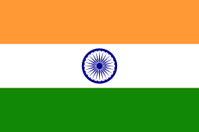
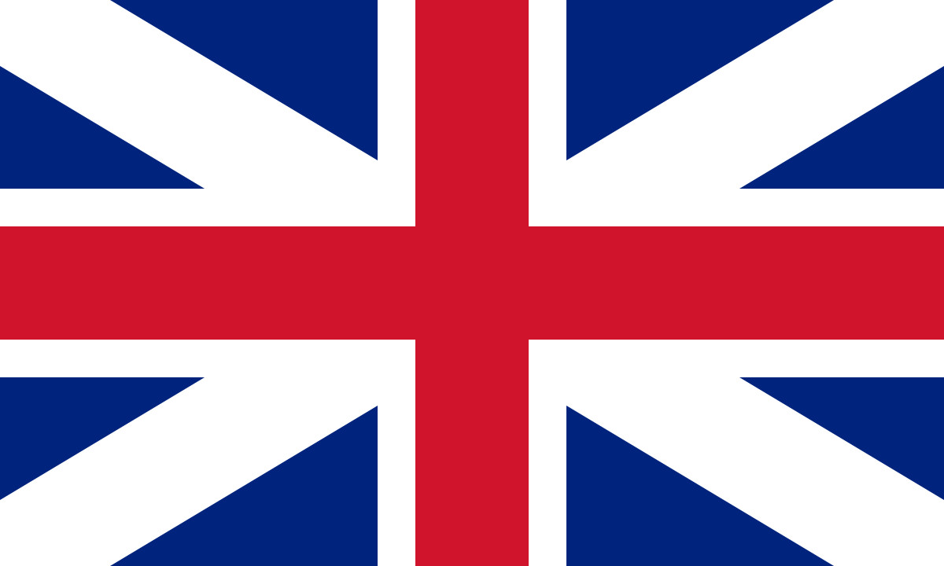
The British Empire
KNOWLEDGE ORGANISER
British Empire Summary  Map showing the approximate extent of the British Empire at its peak. By 1920, the British Empire covered 35,500,000km², around 24% of Earth’s land area. |  | Mughal Empire Summary
The British Empire was the largest empire in history. For over a century, it was the world’s foremost power.  The British Empire was first established as early as 1497, however it reached its peak in the years between 1815 and 1914. This time is often referred to as the ‘British Century.’  The process through which the British (and other nations of the time) began to spread power beyond its borders is called imperialism.  The British Empire was spread as far as New Zealand in the east and Canada in the west. It has hugely influenced societies, cultures, industries and the way that people live across the world. | 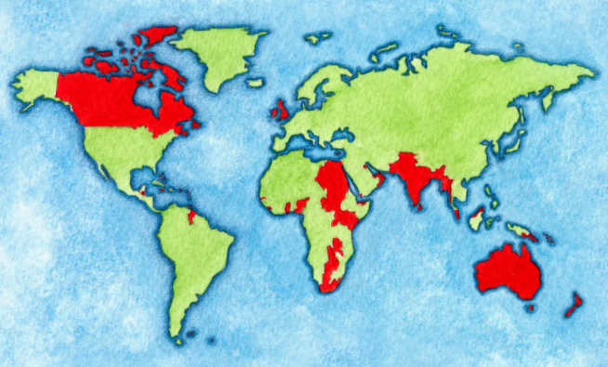
 |  | 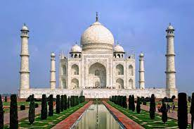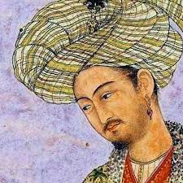
British Empire Major Events
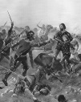  Beginnings  -During the Middle Ages, the kings of England tried to conquer other countries.  -As early as 1169, the Normans invaded Ireland.  -In 1277, Edward I conquered North Wales.  -In the Hundred Years War (1337-1453), Edward III and Henry V conquered large parts of France.  -By 1500, much of the gained land had been lost. | The First British Empire (1497-1783)  -Throughout this time, English seamen reached places that Europeans had not previously been. They set up colonies there so that they could trade the resources.  -The first English colonies were in North America.  -Britain fought wars to protect its empire, including the 7 Years’ War with France. Many American territories were lost in the American War of Independence.
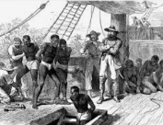  The Transatlantic Slave Trade  -One of the more horrific parts of the British Empire was its position at the heart of the Transatlantic Slave Trade.  -For 400 years from the 15th Century, British slave traders are estimated to have bought or sold around 3 million slaves. Slavery made Britain incredibly wealthy.  -Britain banned slave trading in its empire from 1807. | The Second British Empire (1783-1914)  -Britain began to look towards other areas of the world, for example Asia and Australia, to fulfil its imperial ambitions. Areas of India, the Caribbean and New Zealand were added to the Empire, which grew massively. Britons at the time were proud of the Empire and its power, however those living in colonies experienced inequality and loss of culture & religion. | Important People  - Clive of India (1725-1774)- Governor of Bengal, victorious at the Battle of Plassey, lay the foundation for British rule in India  - Babur (1483-1530)- the founder of the Mughal Empire in the Indian subcontinent  - Aurangzeb (1618-1707)- the sixth emperor of the Mughals, when the Empire was at its greatest. Considered to be the last effective Mughal ruler  - Shah Jahan (1592-1666)- the fifth emperor of the Mughals, buried in the Taj Mahal
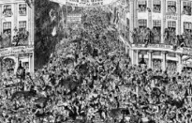
The End of the British Empire

-Towards the end of the 19th Century, a number of states became ‘dominions’, meaning that they remained part of the empire, but governed themselves.
-During the First and Second World War, Britain relied heavily upon its empire in order to win. The countries who supported Britain began to take an increasingly independent view. Furthermore, the wars left Britain weakened and less interested in its empire than it had been previously.
-By the late 1970s, the empire became reduced to a few pockets of territory around the world. Most people view the official end of the empire as the transfer of Hong Kong back to China in 1997.
Key Vocabulary
- Trade
- Imperialism
- Colonies
- Indian Mutiny
- East India Company

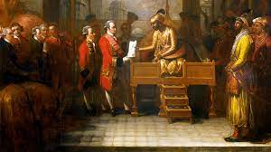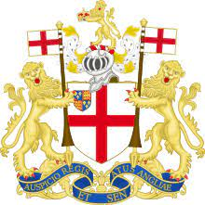
However, the Mughal Empire did come to an end. The Mughal army was weak and lost land to the Afghans in the Punjab region and the Marathas in Southern India. The Mughal Empire was difficult to control and crushing rebellions cost a lot of money. This vulnerable state allowed Britain to take advantage.

In the 1700s, Britain started to build trading stations in India. The East India Company was an example, and it gradually took control of land and trade in areas of India. The company had its own army and won important battles like Plassey in 1756.
The East India Company controlled the Mughal Emperors and ruled parts of India. In 1858, India became part of the British Empire known as the British Raj.

The Mughal Empire was an empire that stretched from Afghanistan in the West and Bangladesh in the East, including parts of India. The Mughals were Muslims who ruled from 1526 until 1857. The Mughal invasion is why there are so many Muslims in India today.
The Mughal Empire was founded by Babur who travelled from modern-day Uzbekistan, through Afghanistan to India where he had major victories and captured key cities like Delhi.
The Mughals became rich and powerful. The Taj Mahal was built under Shah Jahan’s reign in the mid-1600s. The wealth of the Mughals came from a booming cotton trade, advanced shipbuilding, vast farmland and new road systems. The rise of the Mughals was helped by the fact Hindus, Muslims and Sikhs worked together and got along for many years.

Post 1918: Attitudes towards imperialism begin to change.
1876 – Queen Victoria is named the ‘Empress of India.’
1787 – First shipment of prisoners to Australia.
1867 – Canada given ‘dominion’ (self-governing) status.
1775-1783 – American War of Independence
1653- The Taj Mahal is completed in Agra, India
1577-1580 – Sir Francis Drake completes his circumnavigation of the world.
1600 – The Formation of the East India Company.
1526- Babur is the first Emperor of the Mughal Empire
pre-1497CE – British rulers attempt to conquer new lands.

Timeline

