11.05.20 LCT Update to Parents

Dear Parents,

I do hope you and your families continue to be safe and well.

I did not write to you at the end of last week as I was waiting for the Prime Minister’s announcement last night in order to understand the Government’s strategy for the reopening of schools. I, like many of you, have more questions than answers at this stage and we are now awaiting further guidance from the Department of Education over the next few days. We need to have time to review this and agree next steps with our Headteachers before we can give you any further information. Please be assured that the safety of our children and staff are paramount and we will be ensuring this is a priority in our planning.

We will continue to provide and support Home Learning, as well as a provision for the children of key workers and those requiring additional support in our schools each day.

I know that at this stage we need to continue to follow all the national guidance, keep everyone safe and make sure that this awful virus does not spread but is contained and the risk to life significantly reduced.

I will be in touch later this week.

Yours sincerely,
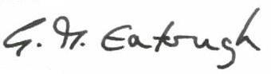
Dr. Gill Eatough
CEO LCT

